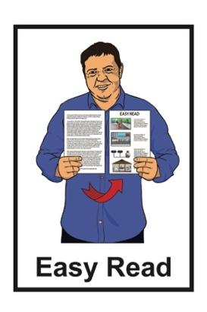
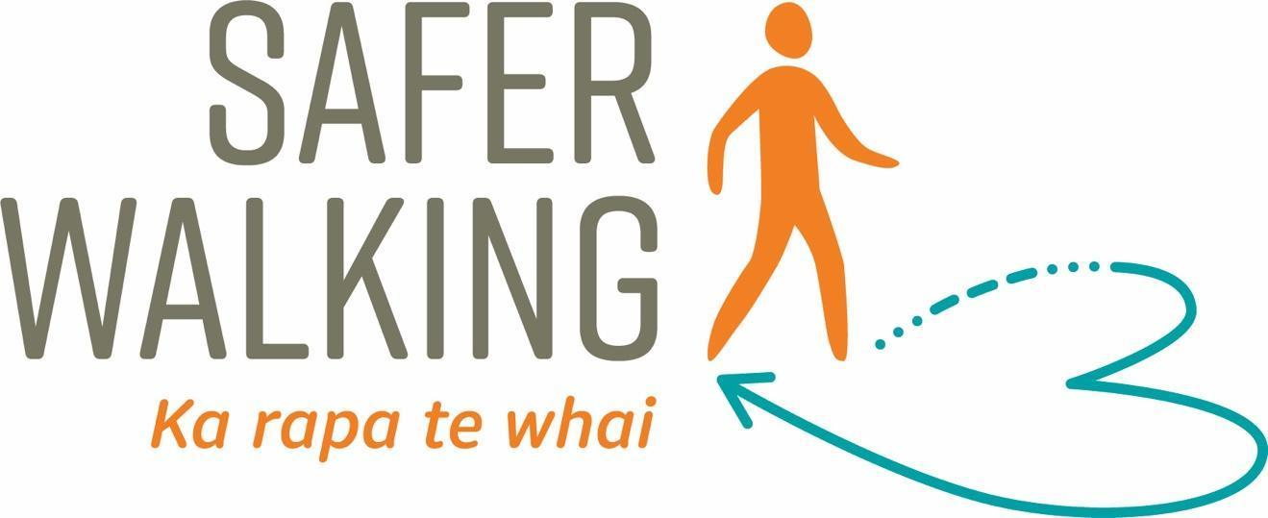



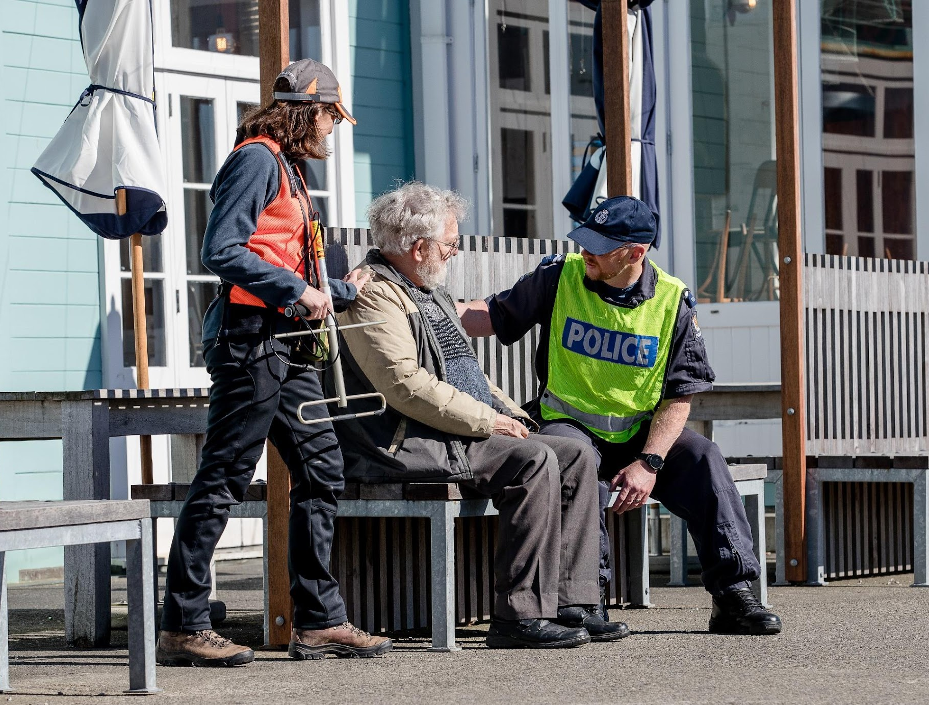
Information about the
Safer Walking framework

Published: April 2026

What you will find in here

Page number:

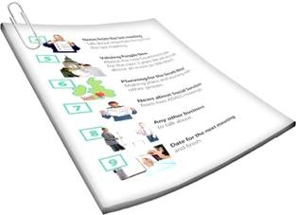
About this Easy Read 2

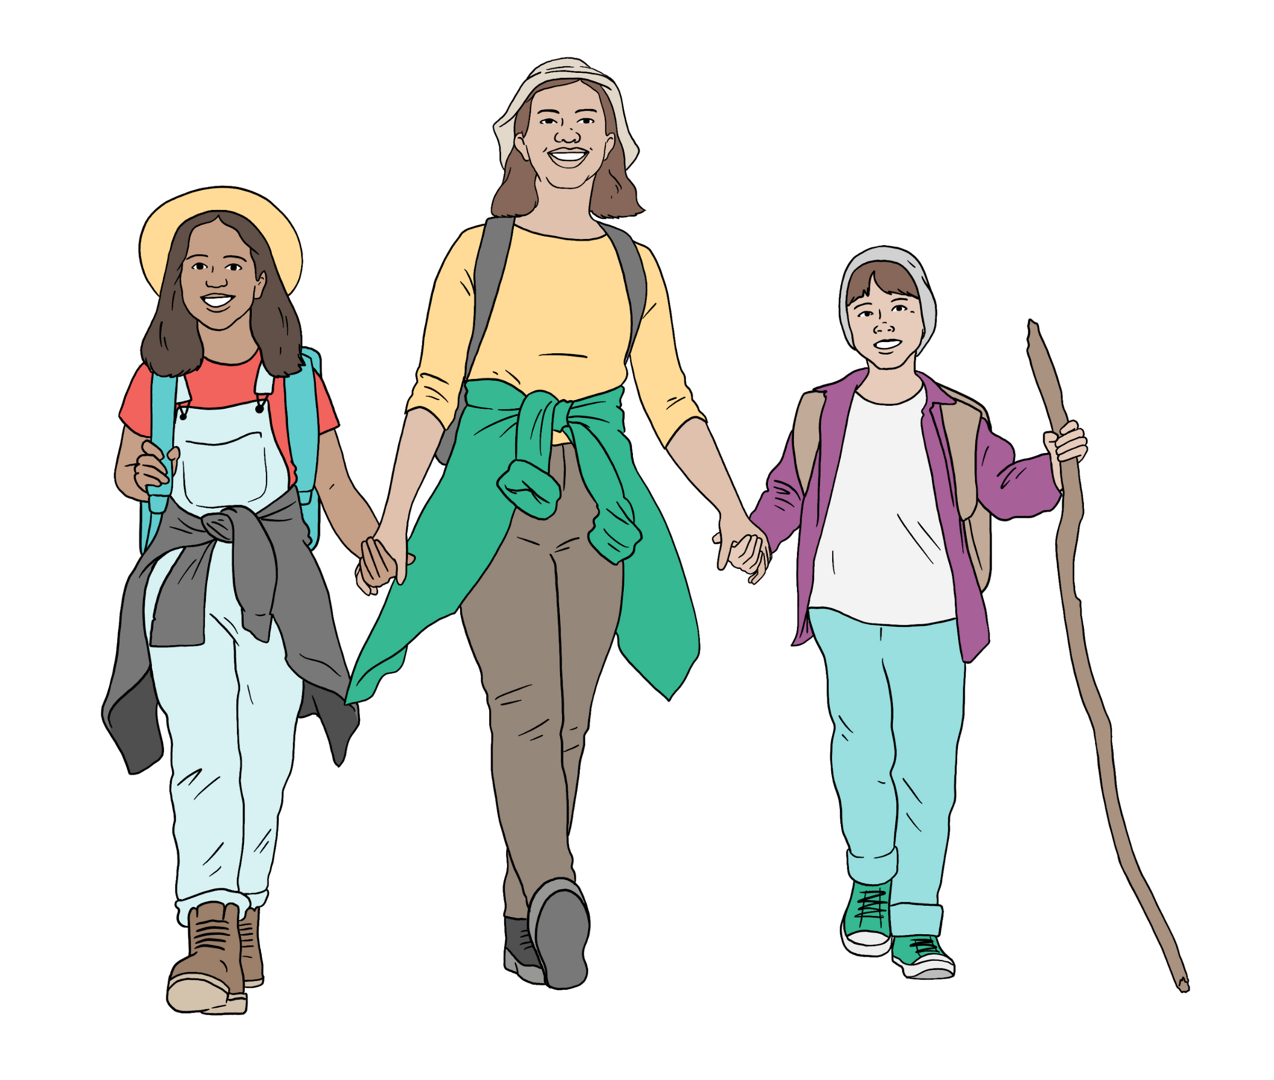
What is the Safer Walking
framework? 7
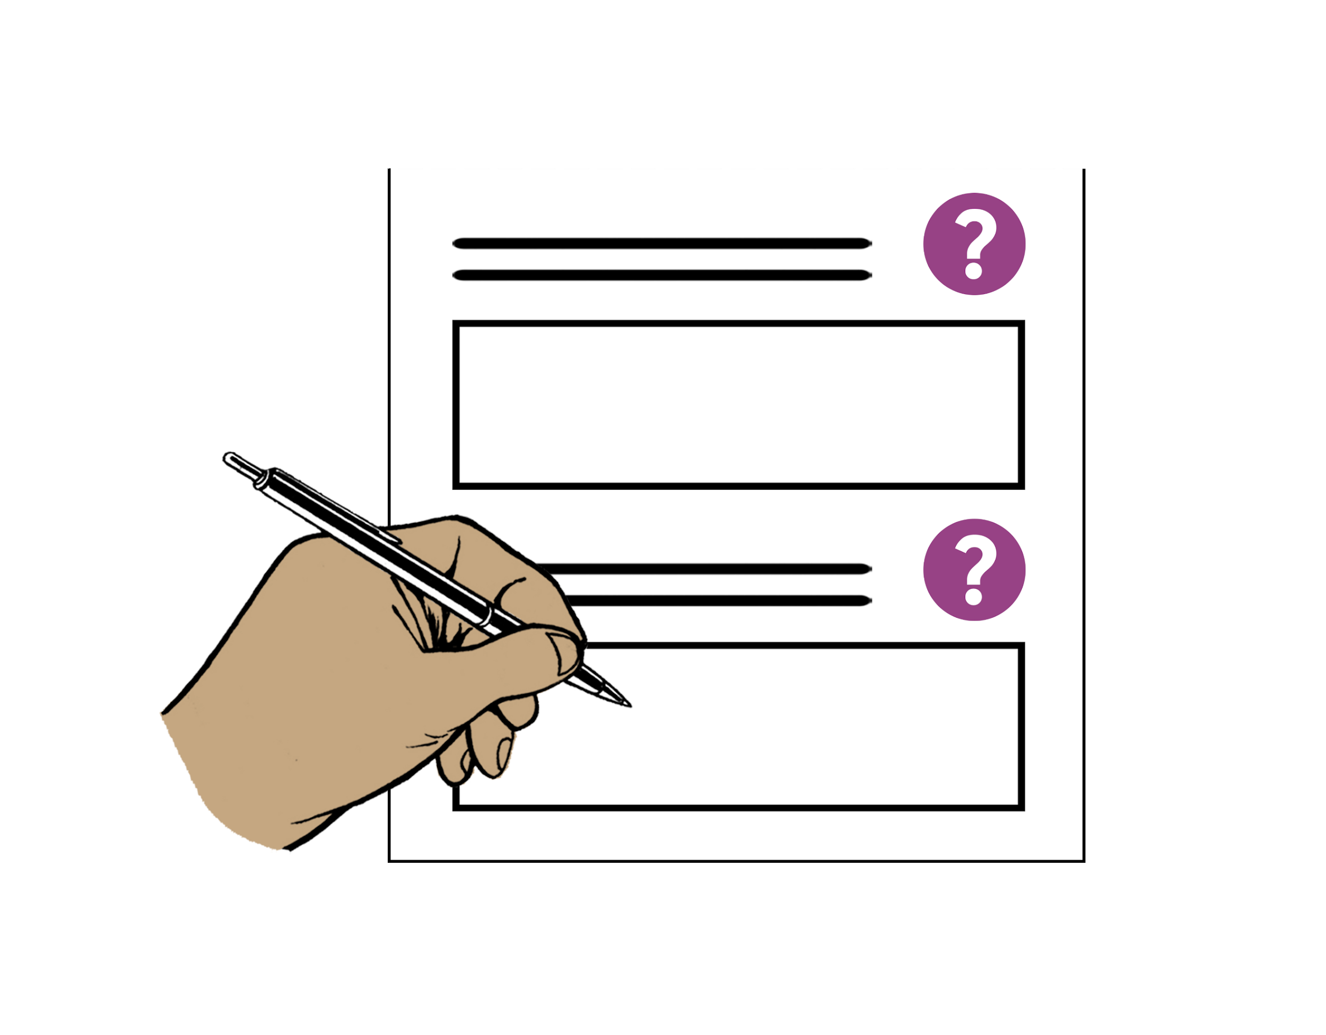

The Safer Walking profile form 10
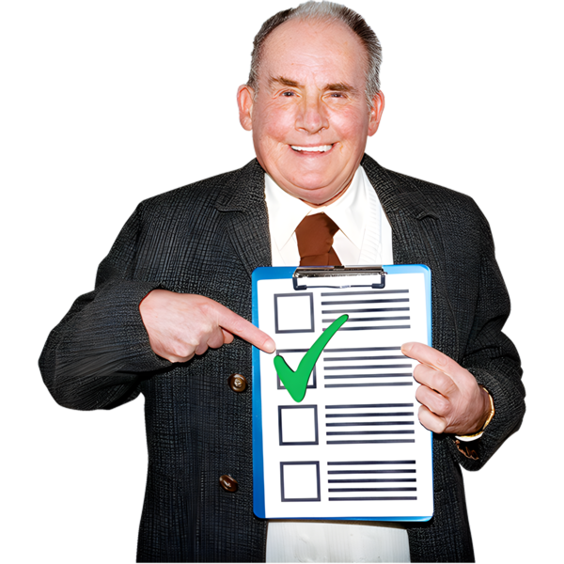

Tips to stay safe 16
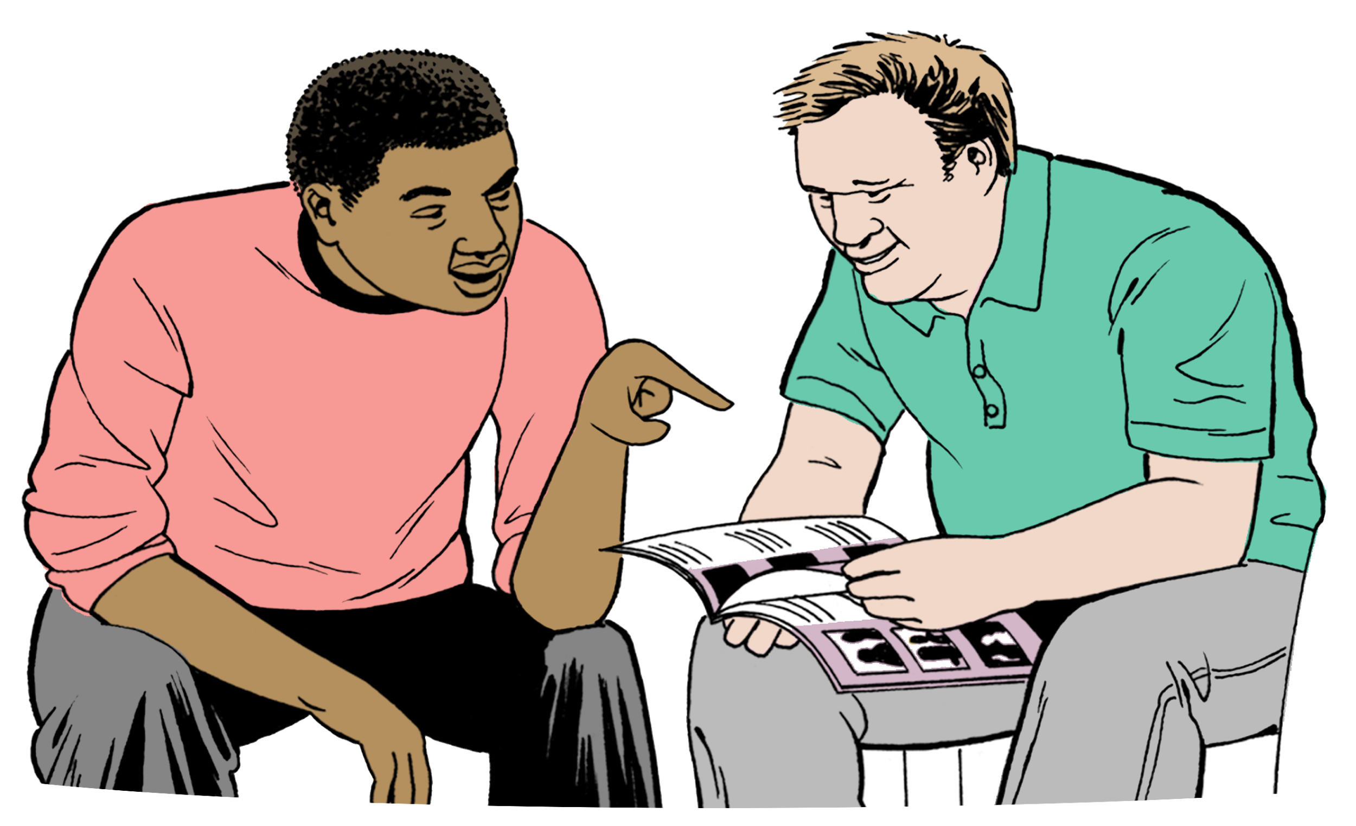

How to get more support 18
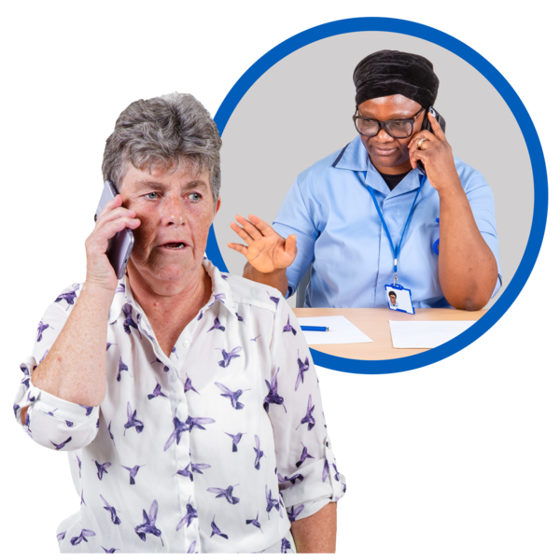

How to contact us 22

About this Easy Read


This Easy Read document tells you:
- about the Safer Walking framework
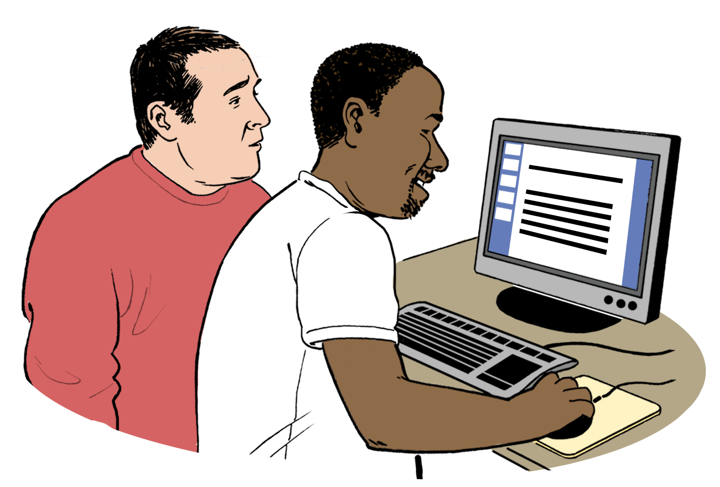
- how this framework can support you.

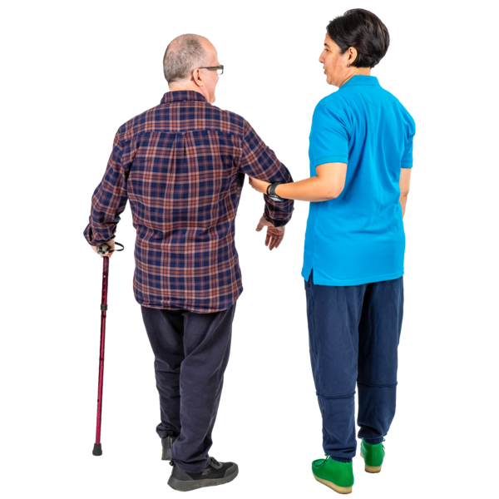
The Safer Walking framework has been made to support people who may be at risk of getting lost like some people who:
- have dementia
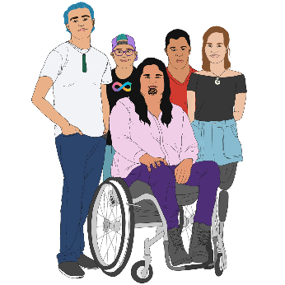
- are neurodivergent
- have a learning disability
- are disabled.


Here a risk is when something might happen to put you in danger.

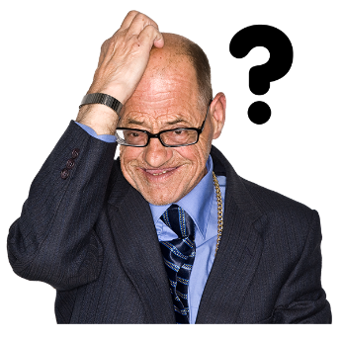
Dementia is a condition where people find it harder to:
- remember things
- understand things.
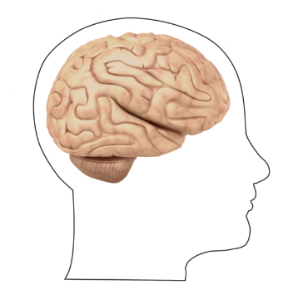

Neurodivergent people have brains that work in different ways to most people like how they:
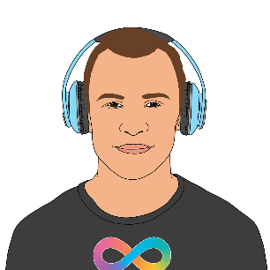
- learn
- process / use information.

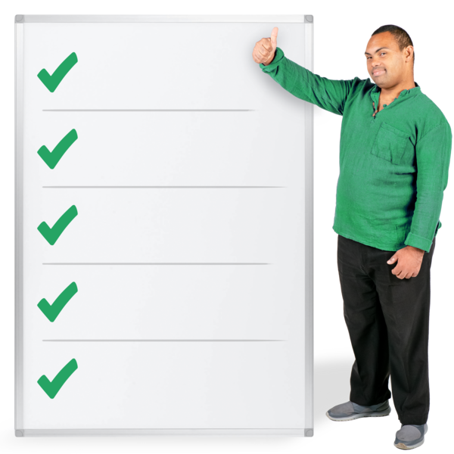
Here framework means the things you can do to assist you to be safe when you are out walking.


The Safer Walking framework is looked after by Land Search and Rescue New Zealand – Rapa Taiwhenua.

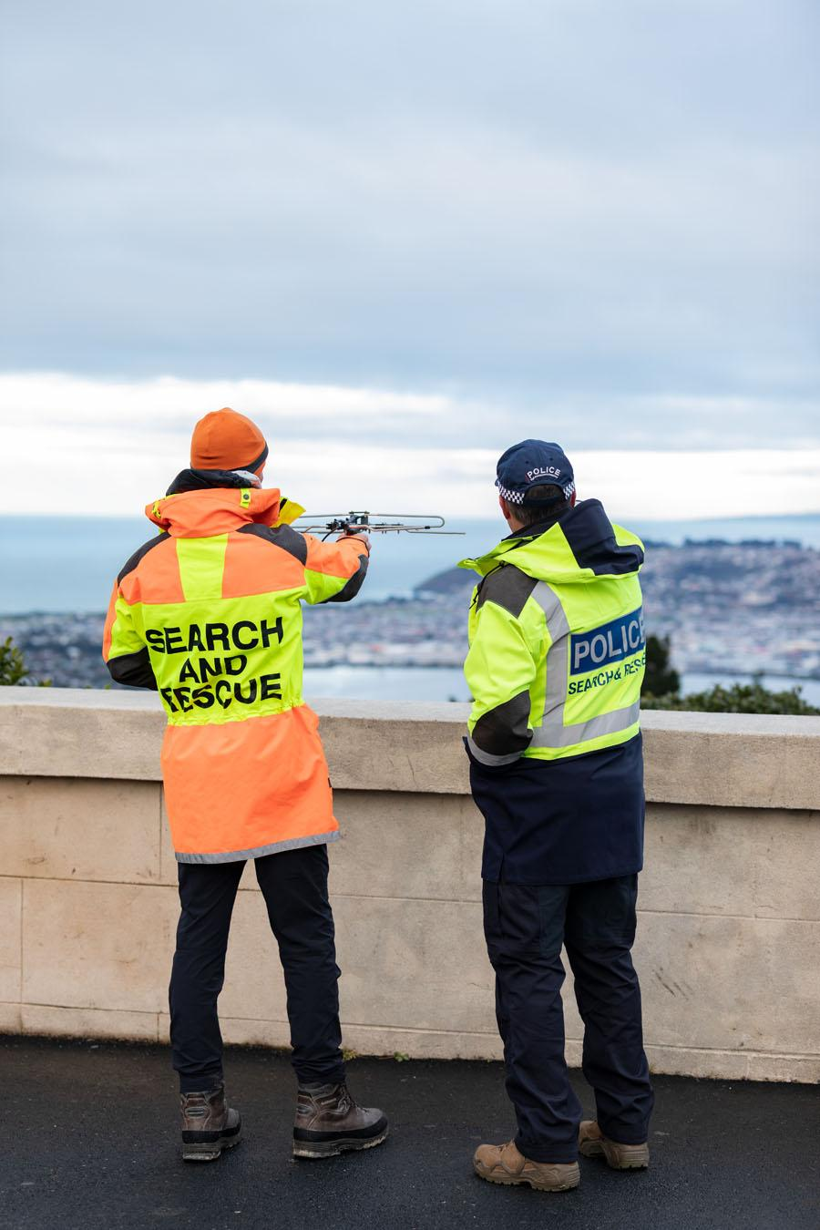
Land Search and Rescue New Zealand – Rapa Taiwhenua is an organisation that looks for people when they are lost / missing in places like:
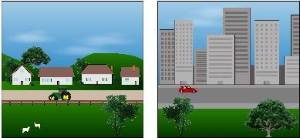
- cities
- the country
- suburbs / neighbourhoods
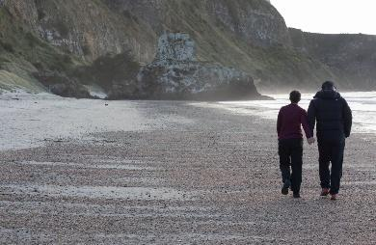
- the bush
- beaches.

Other organisations support Land Search and Rescue New Zealand to do its Safer Walking work like:

- emergency services like the Police
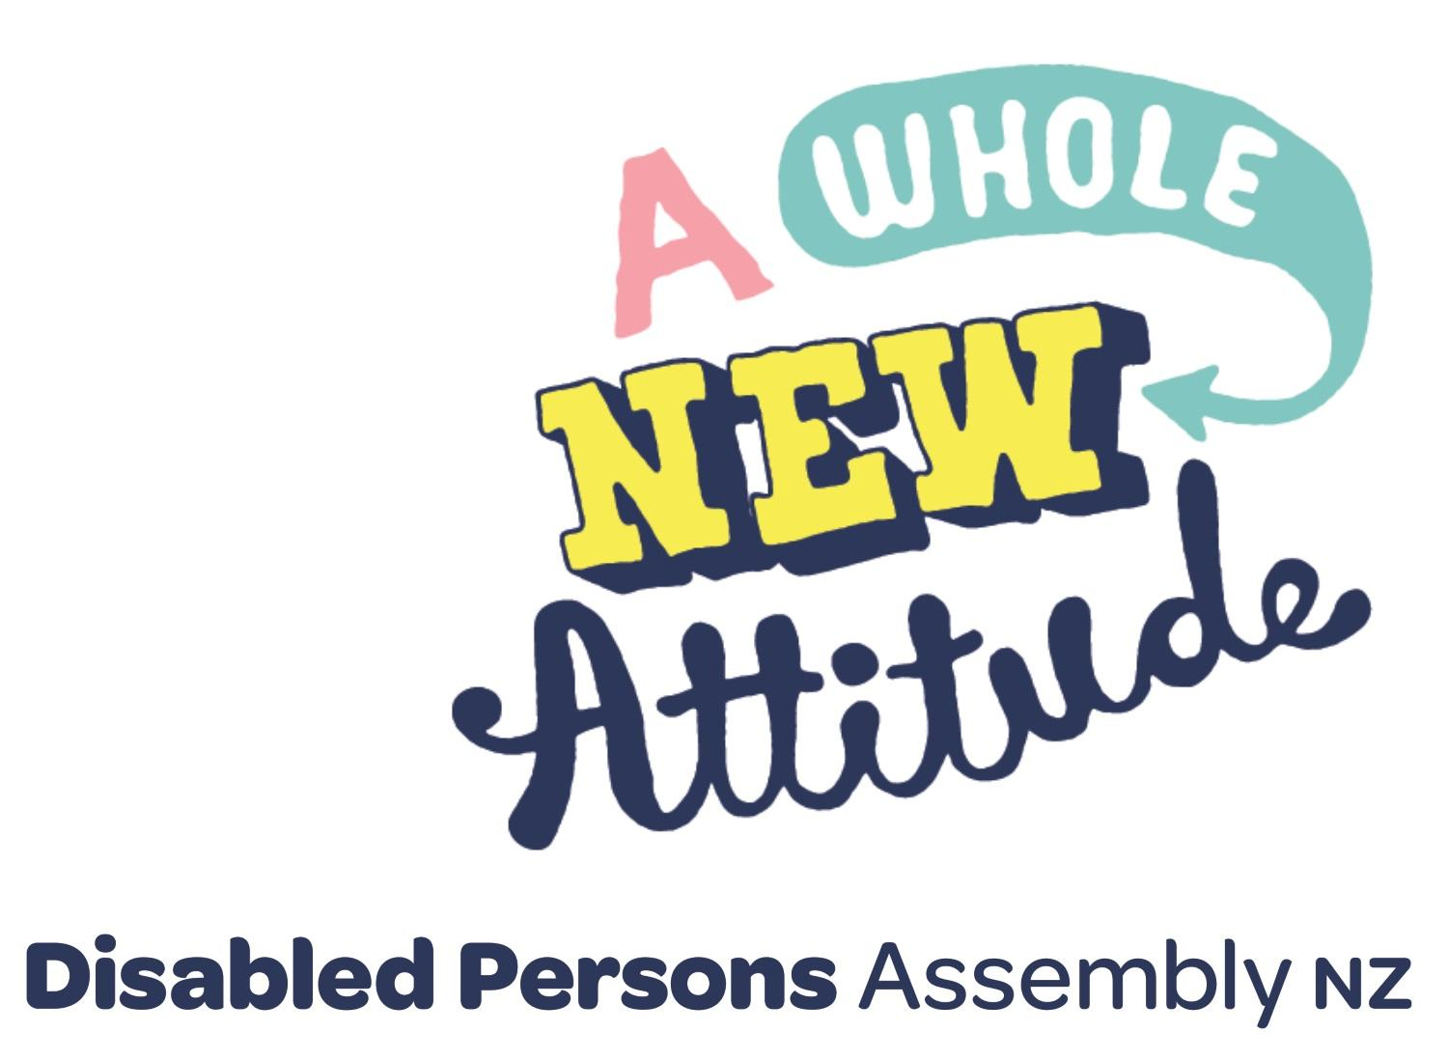
- Disabled Peoples Organisations like:

- the Disabled Peoples Assembly / DPA
- People First.

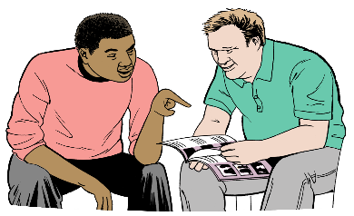
You might want to read this Easy Read with someone you trust like:
- your support worker
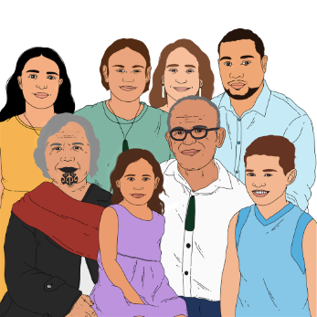
- a friend
- a family member.

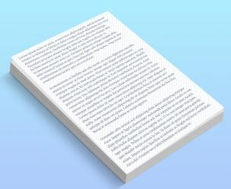
In this Easy Read the words
us / we / our mean the Safer Walking team.


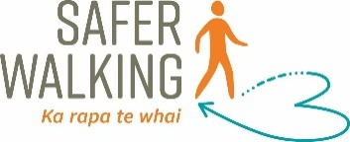

There is more information about the Safer Walking framework at this website:
https://saferwalking.nz

What is the Safer Walking framework?

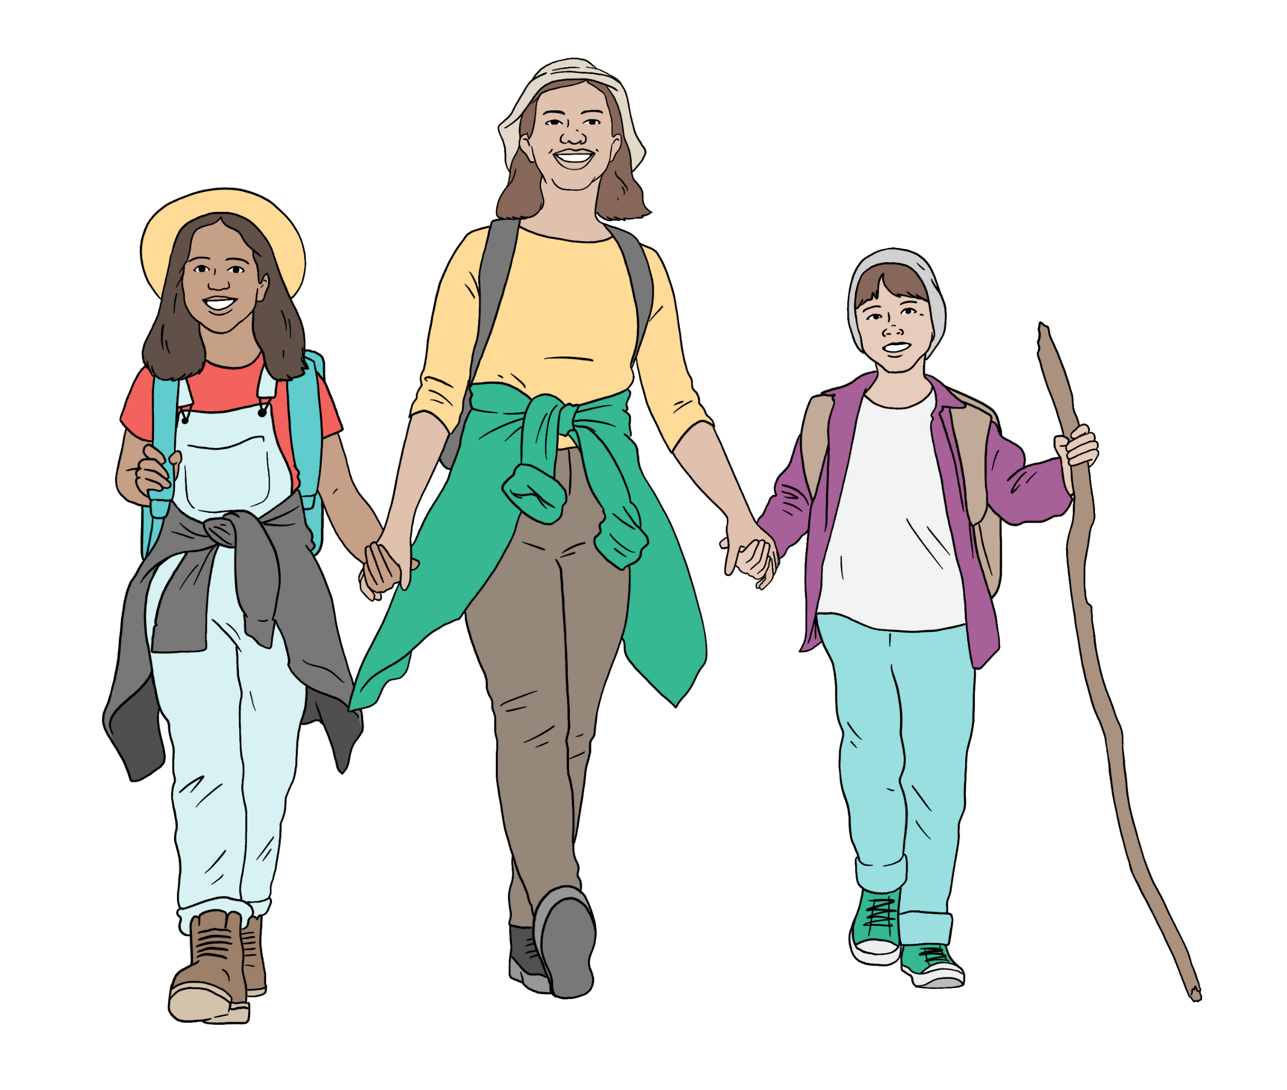
Walking:
- is good for your health
- supports you to stay active.

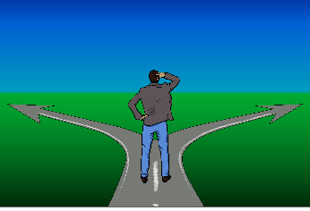
People who are walking can get lost sometimes.


They might know where they want to go but they might not remember how to get there.

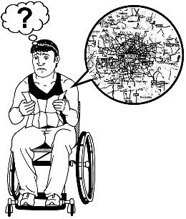
They might:
- go the wrong way
- find it hard to find their way back to where they started.
The Safer Walking framework is made to support people at risk of:
- getting lost
- going missing.

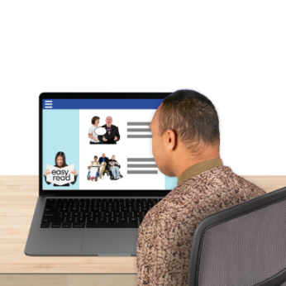
The Safer Walking framework has:
- information about safer walking
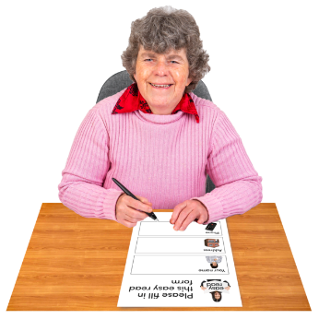
- a website about safer walking
- tools / things to support people to be safe
- a profile form to fill out.
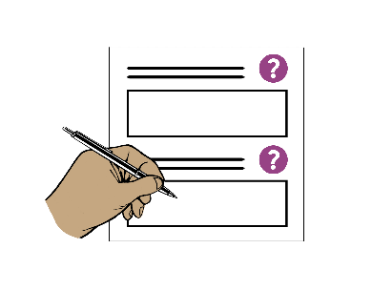

Here a profile form is a form people who are at risk of getting lost fill out.

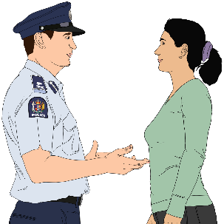
If you get lost / go missing this form
can be given to the Police to support them to find you.
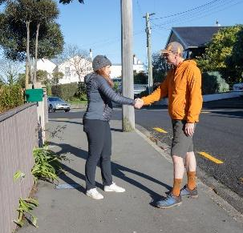
The Safer Walking framework also supports you by:

- teaching you about the risk of getting lost

- reducing the risk of you getting lost.




Here reducing means making something happen less often.

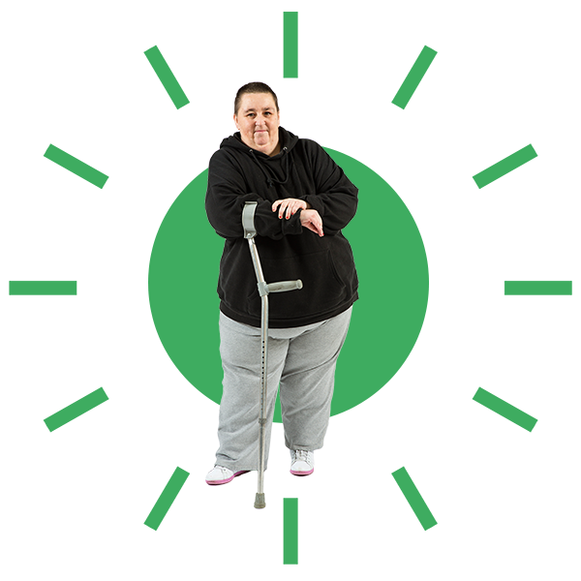
Following the Safer Walking tips will support:

- you to walk safely
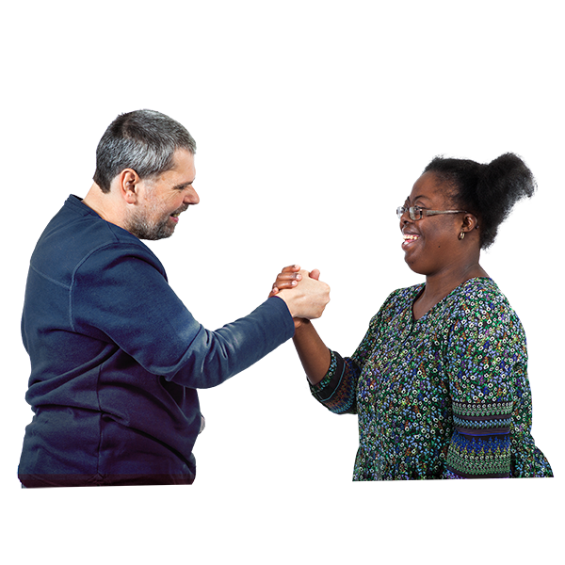
- you to stay independent which means to do things for yourself

- people to know how to support you to stay safe like your:

- friends

- family.

The Safer Walking profile form
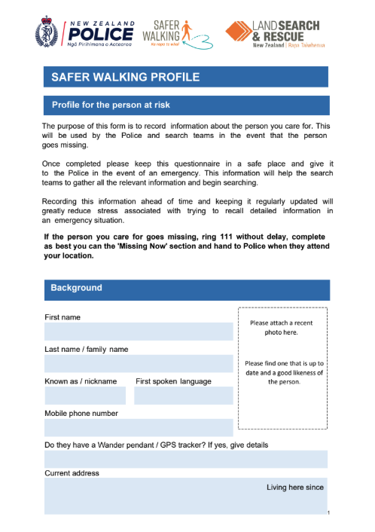

Fill out a Safer Walking profile form if you think you are at risk of:
- getting lost
- going missing.

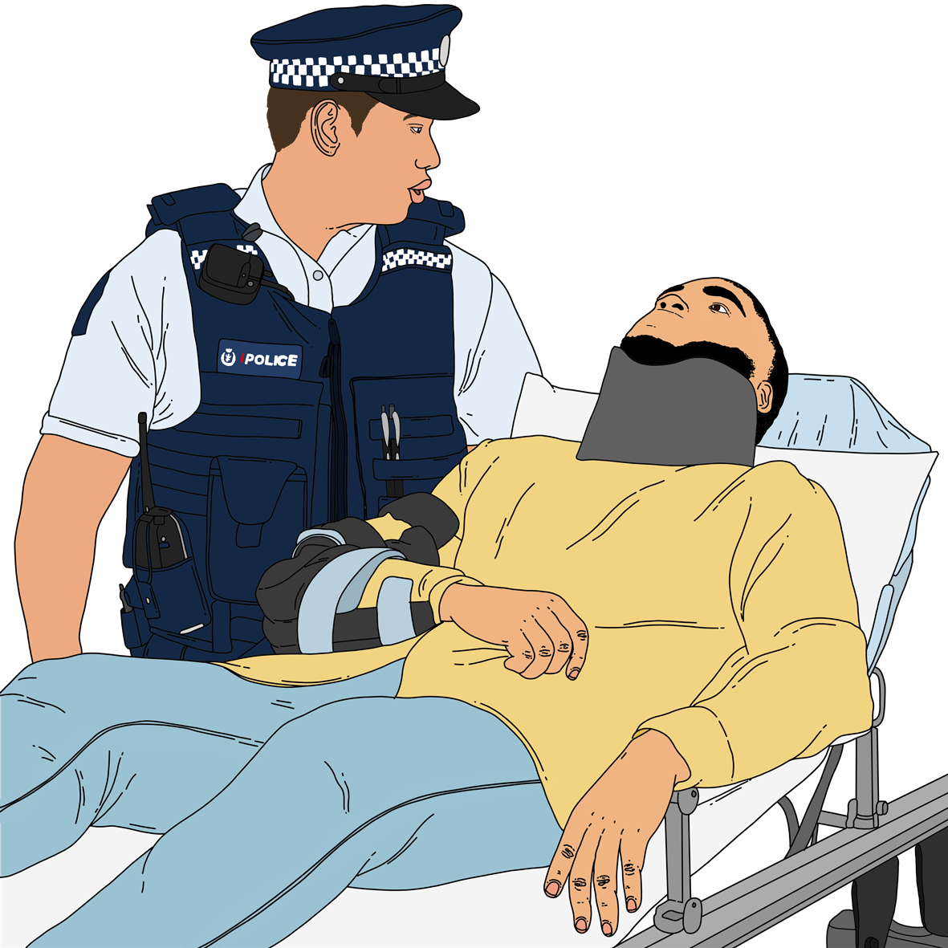
Your profile form can be given to the Police if:
- there is an emergency
- you get lost / go missing.

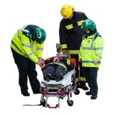
Here an emergency is when something happens that puts you in danger.

The Police will use the information on your profile form to support them to find you quickly.

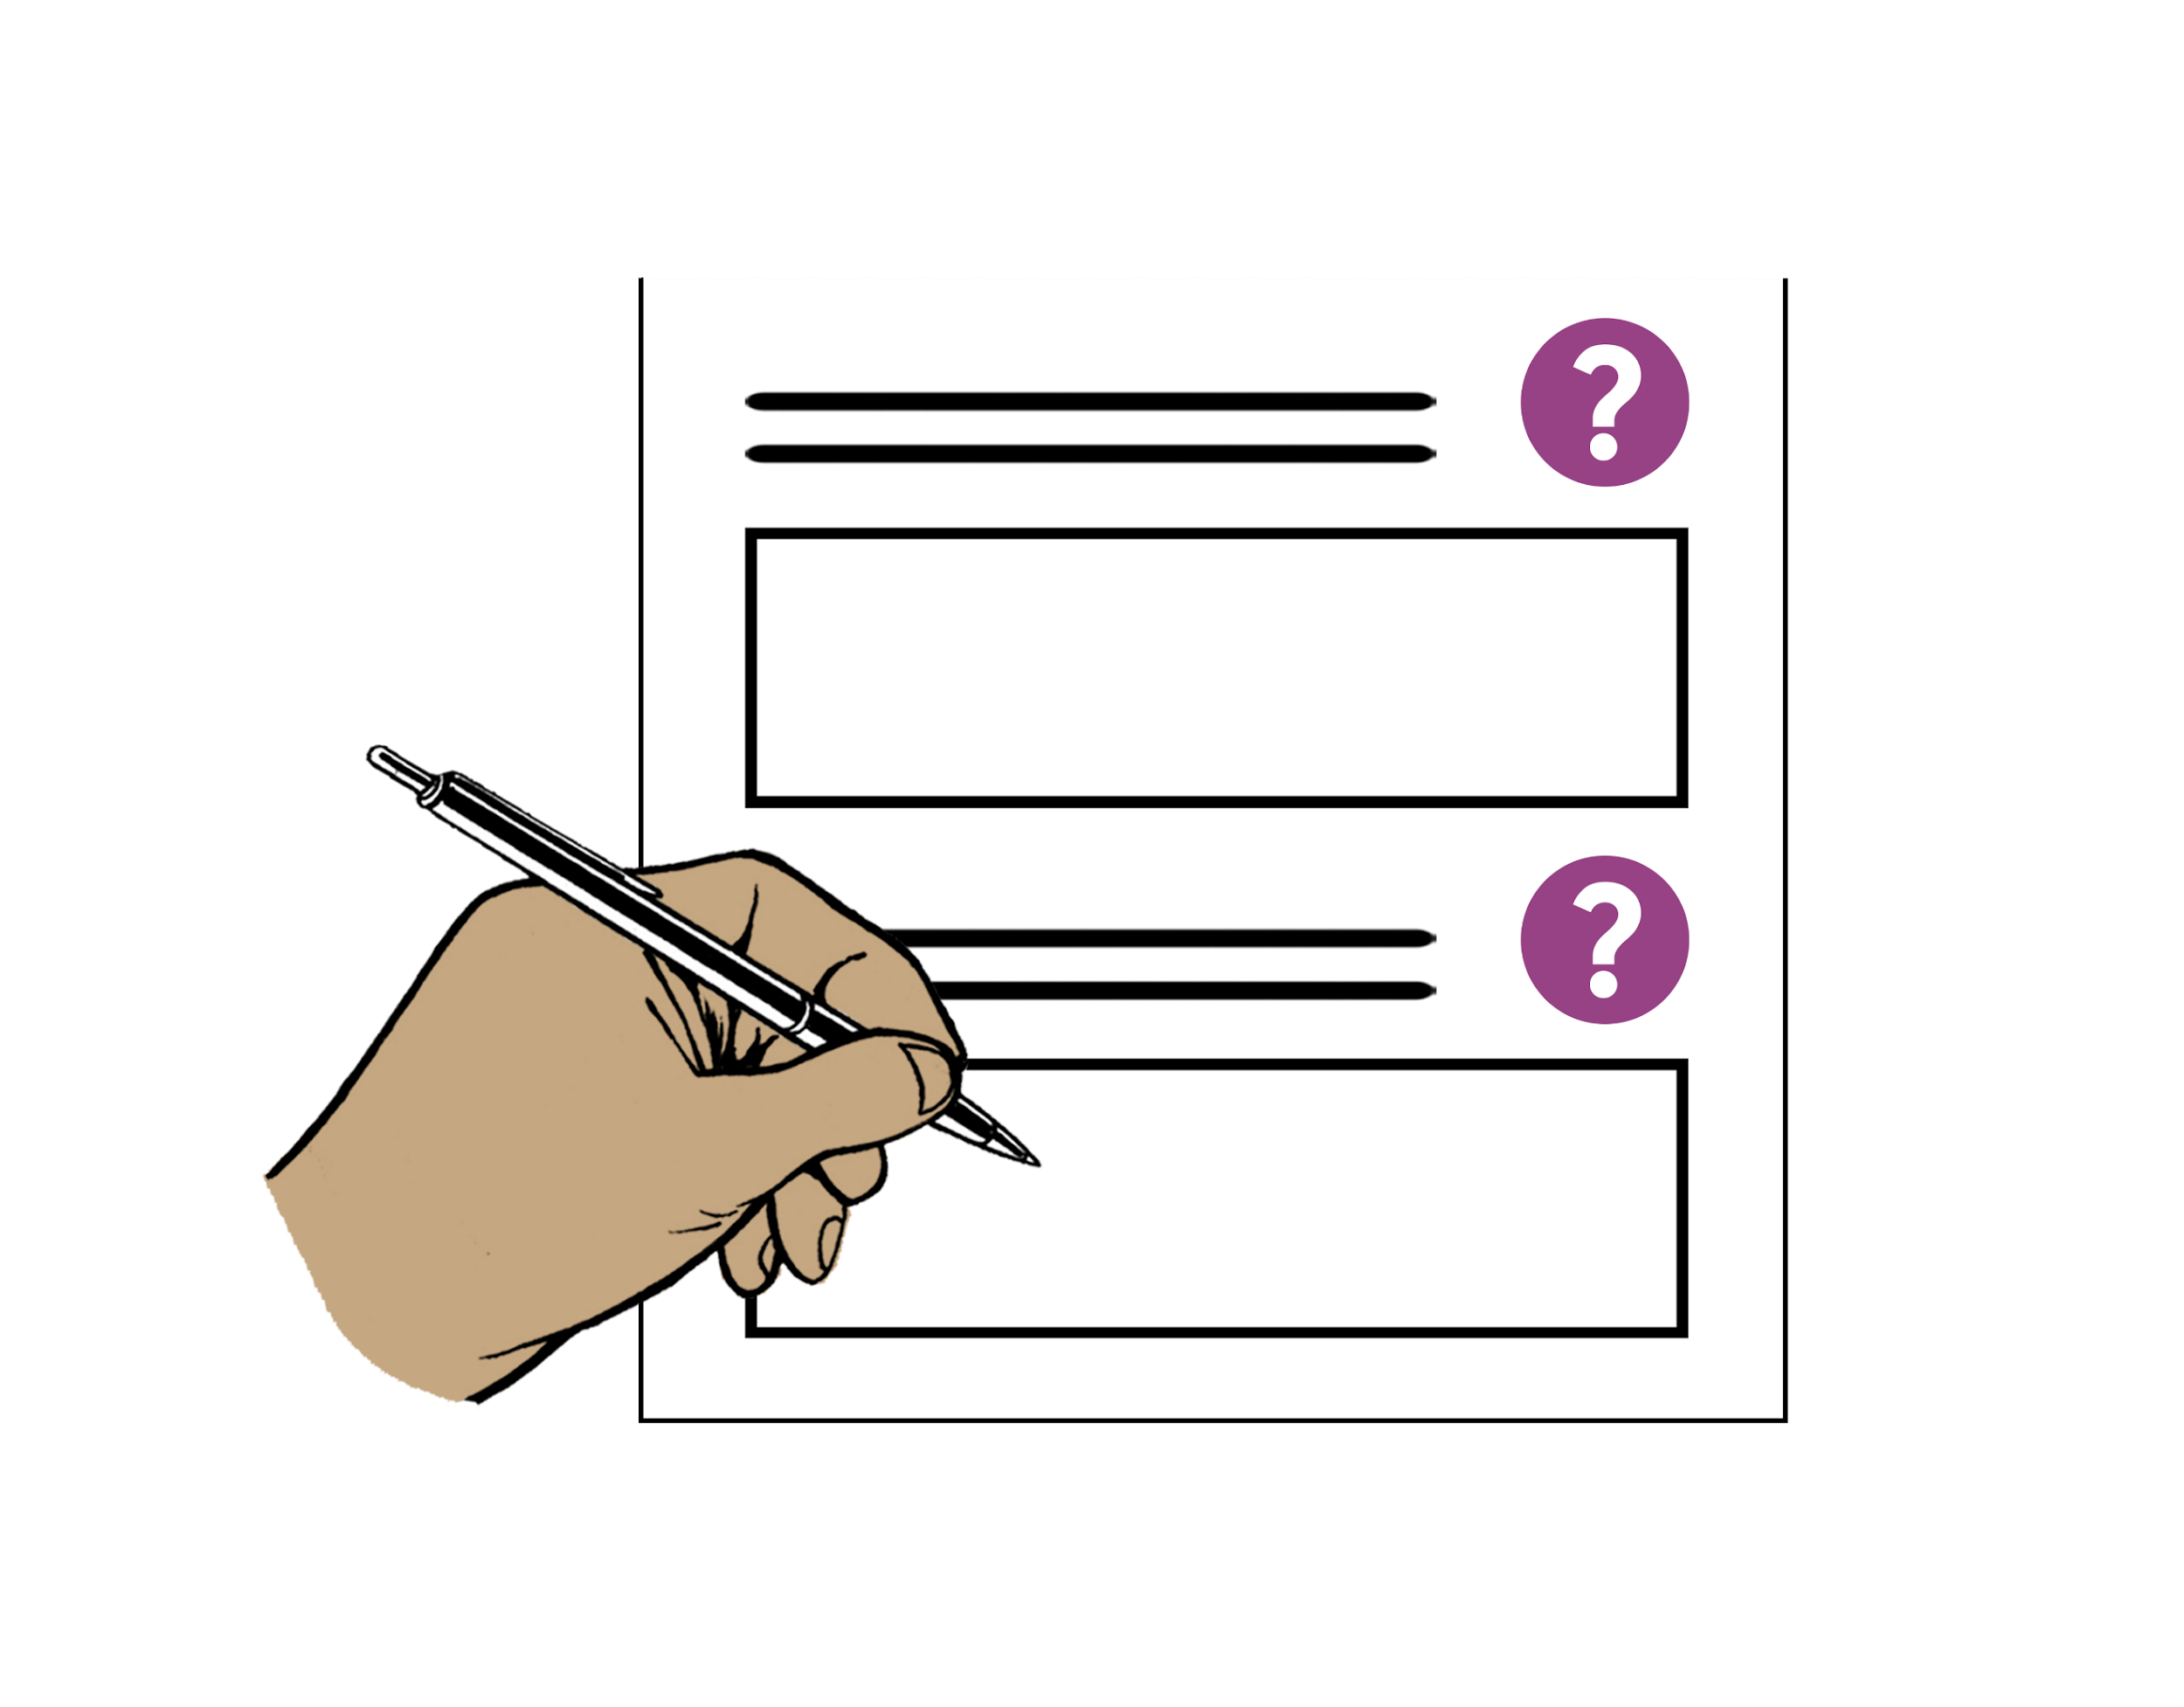

How to complete the Safer Walking profile form

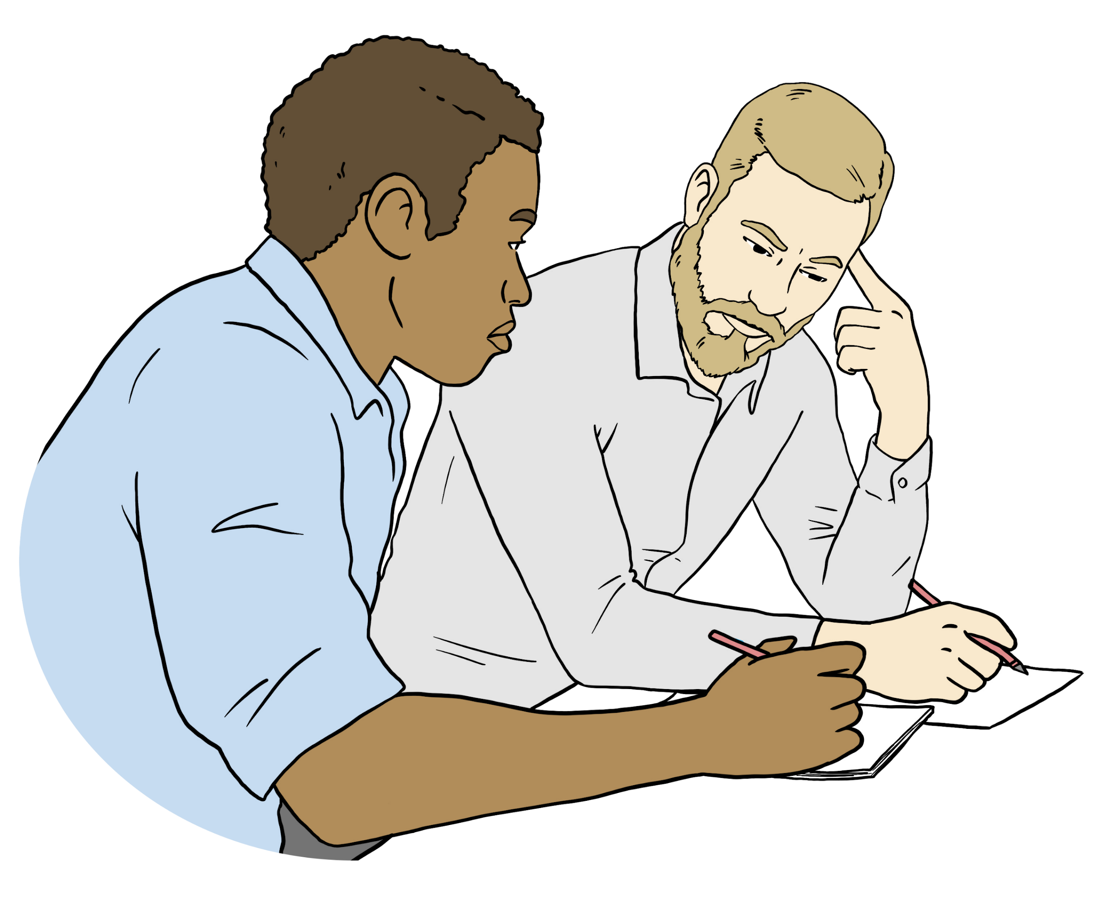
You can ask someone to support you to fill out your profile form like:
- your support worker
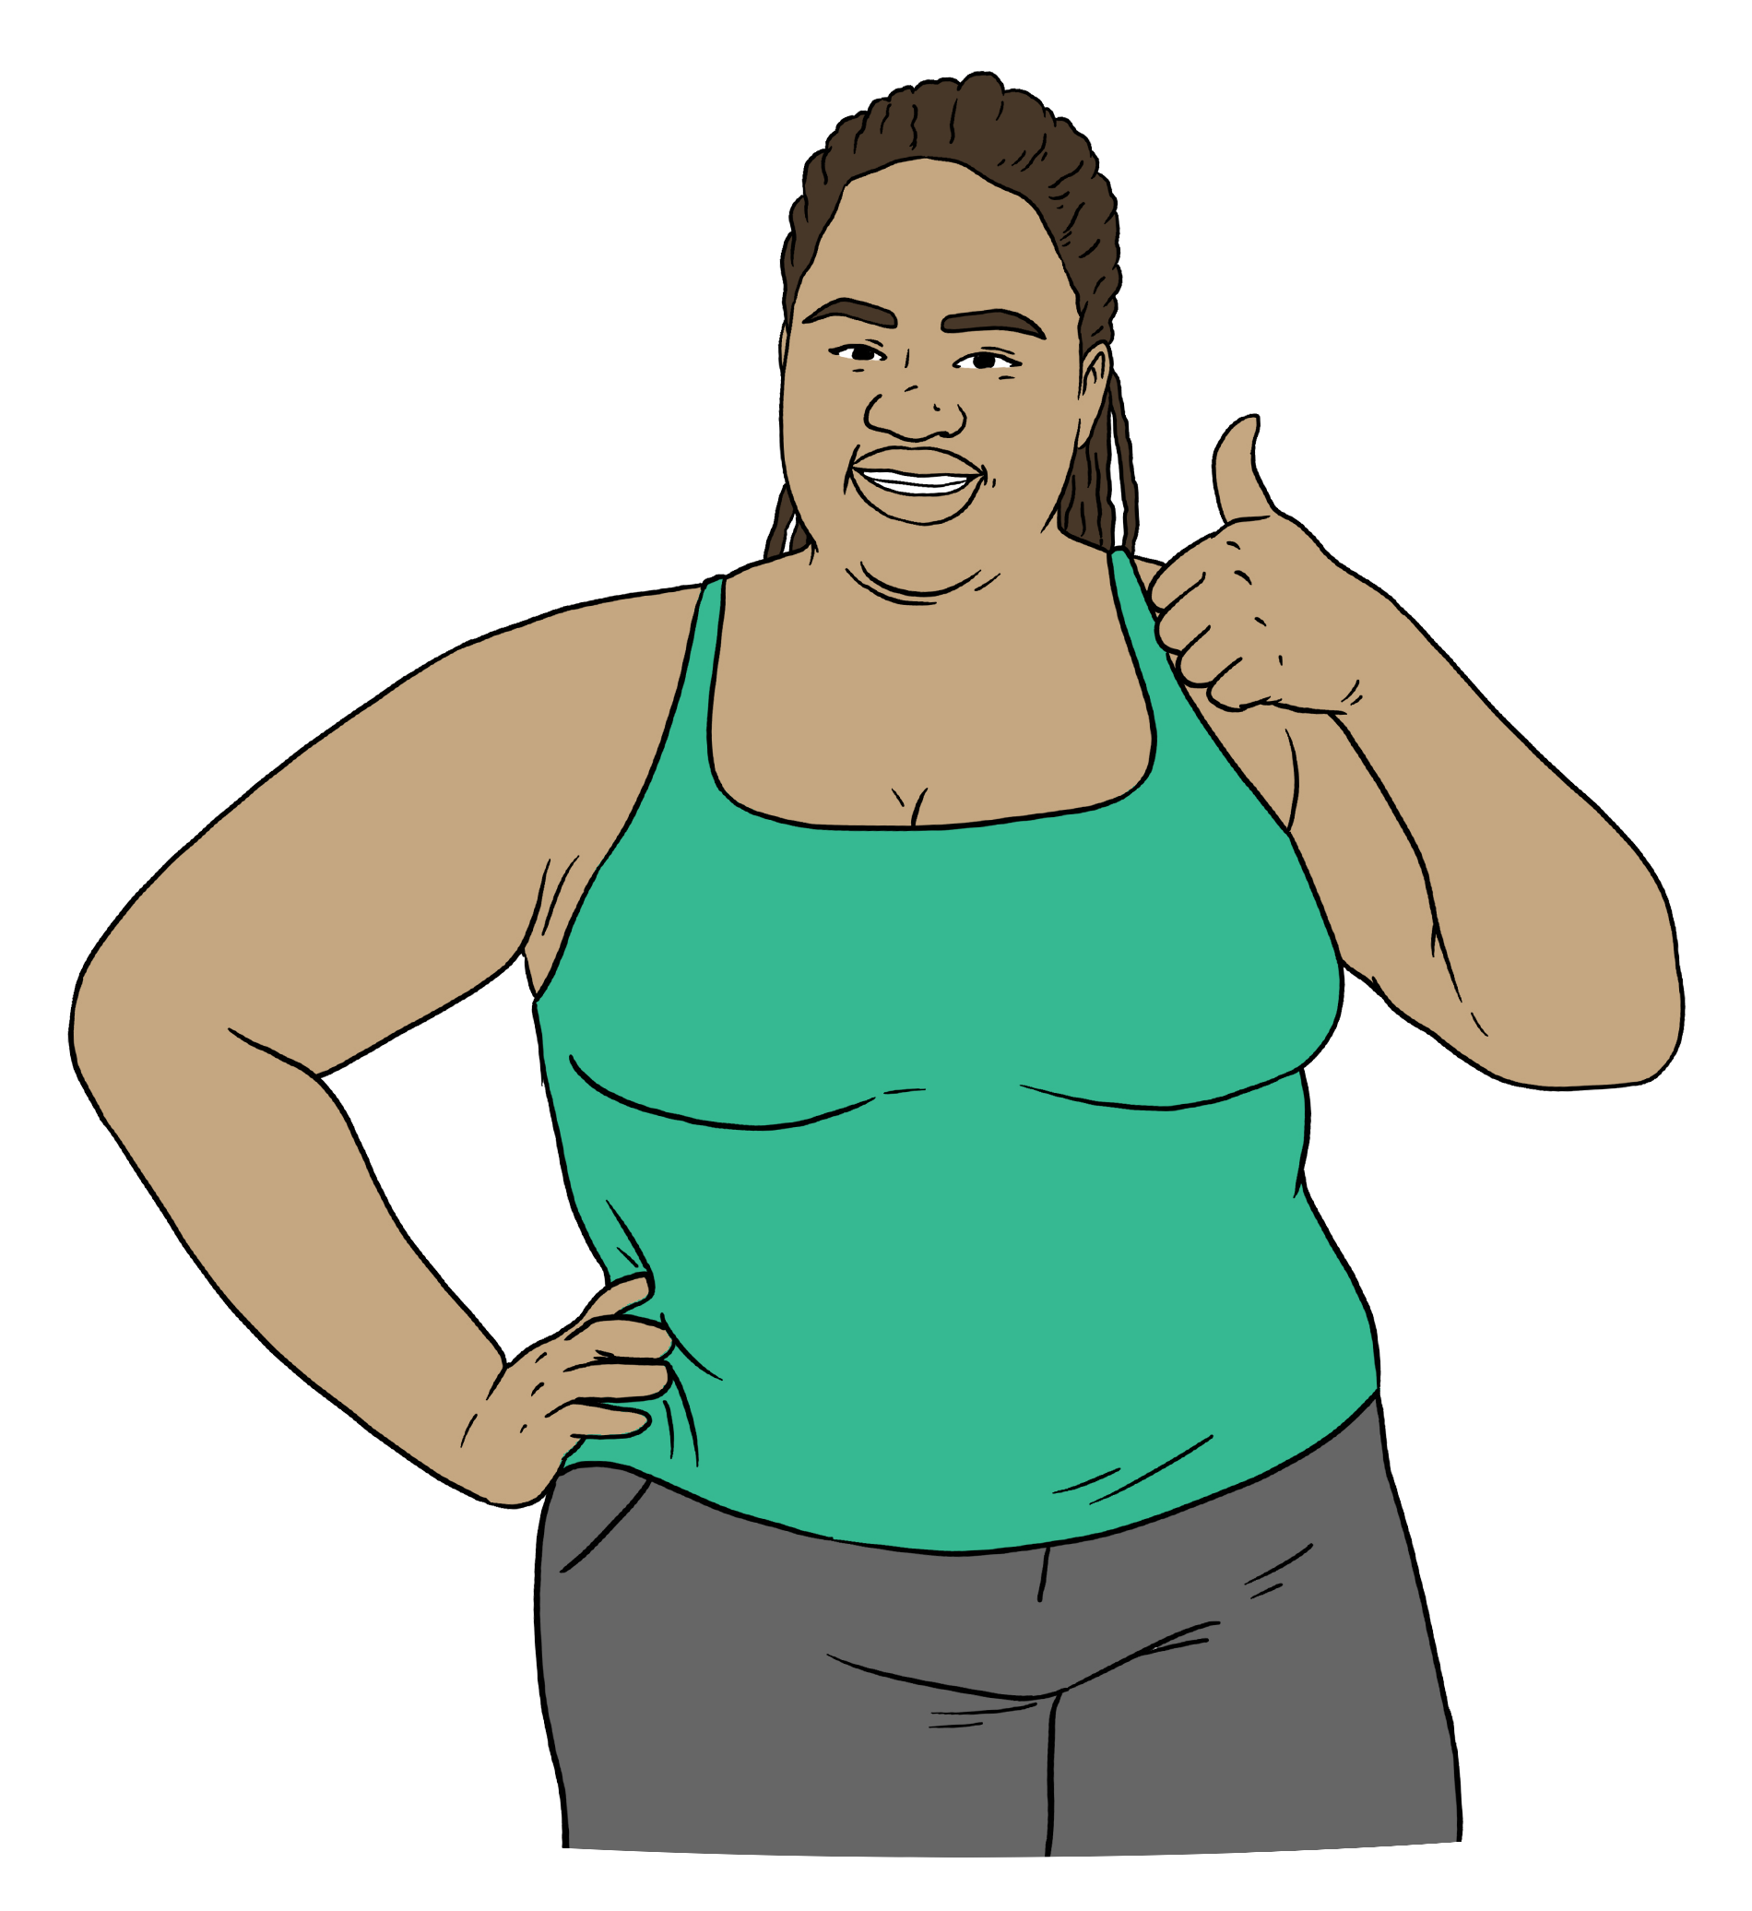
- a family member.

The person you choose to do this will need your permission.


Permission means you:
- have said yes to something
- understand what you have said yes to.
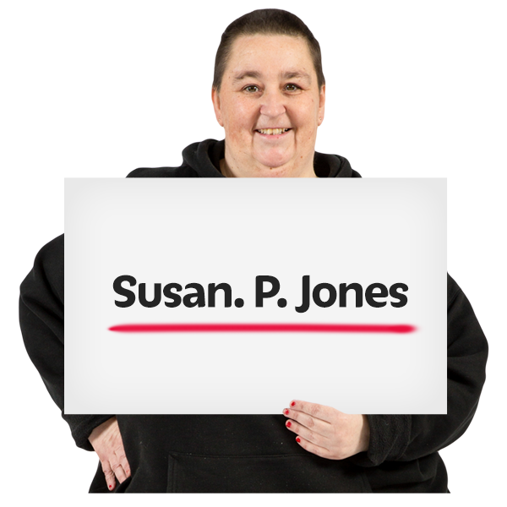
The profile form asks you for things like:
- your name
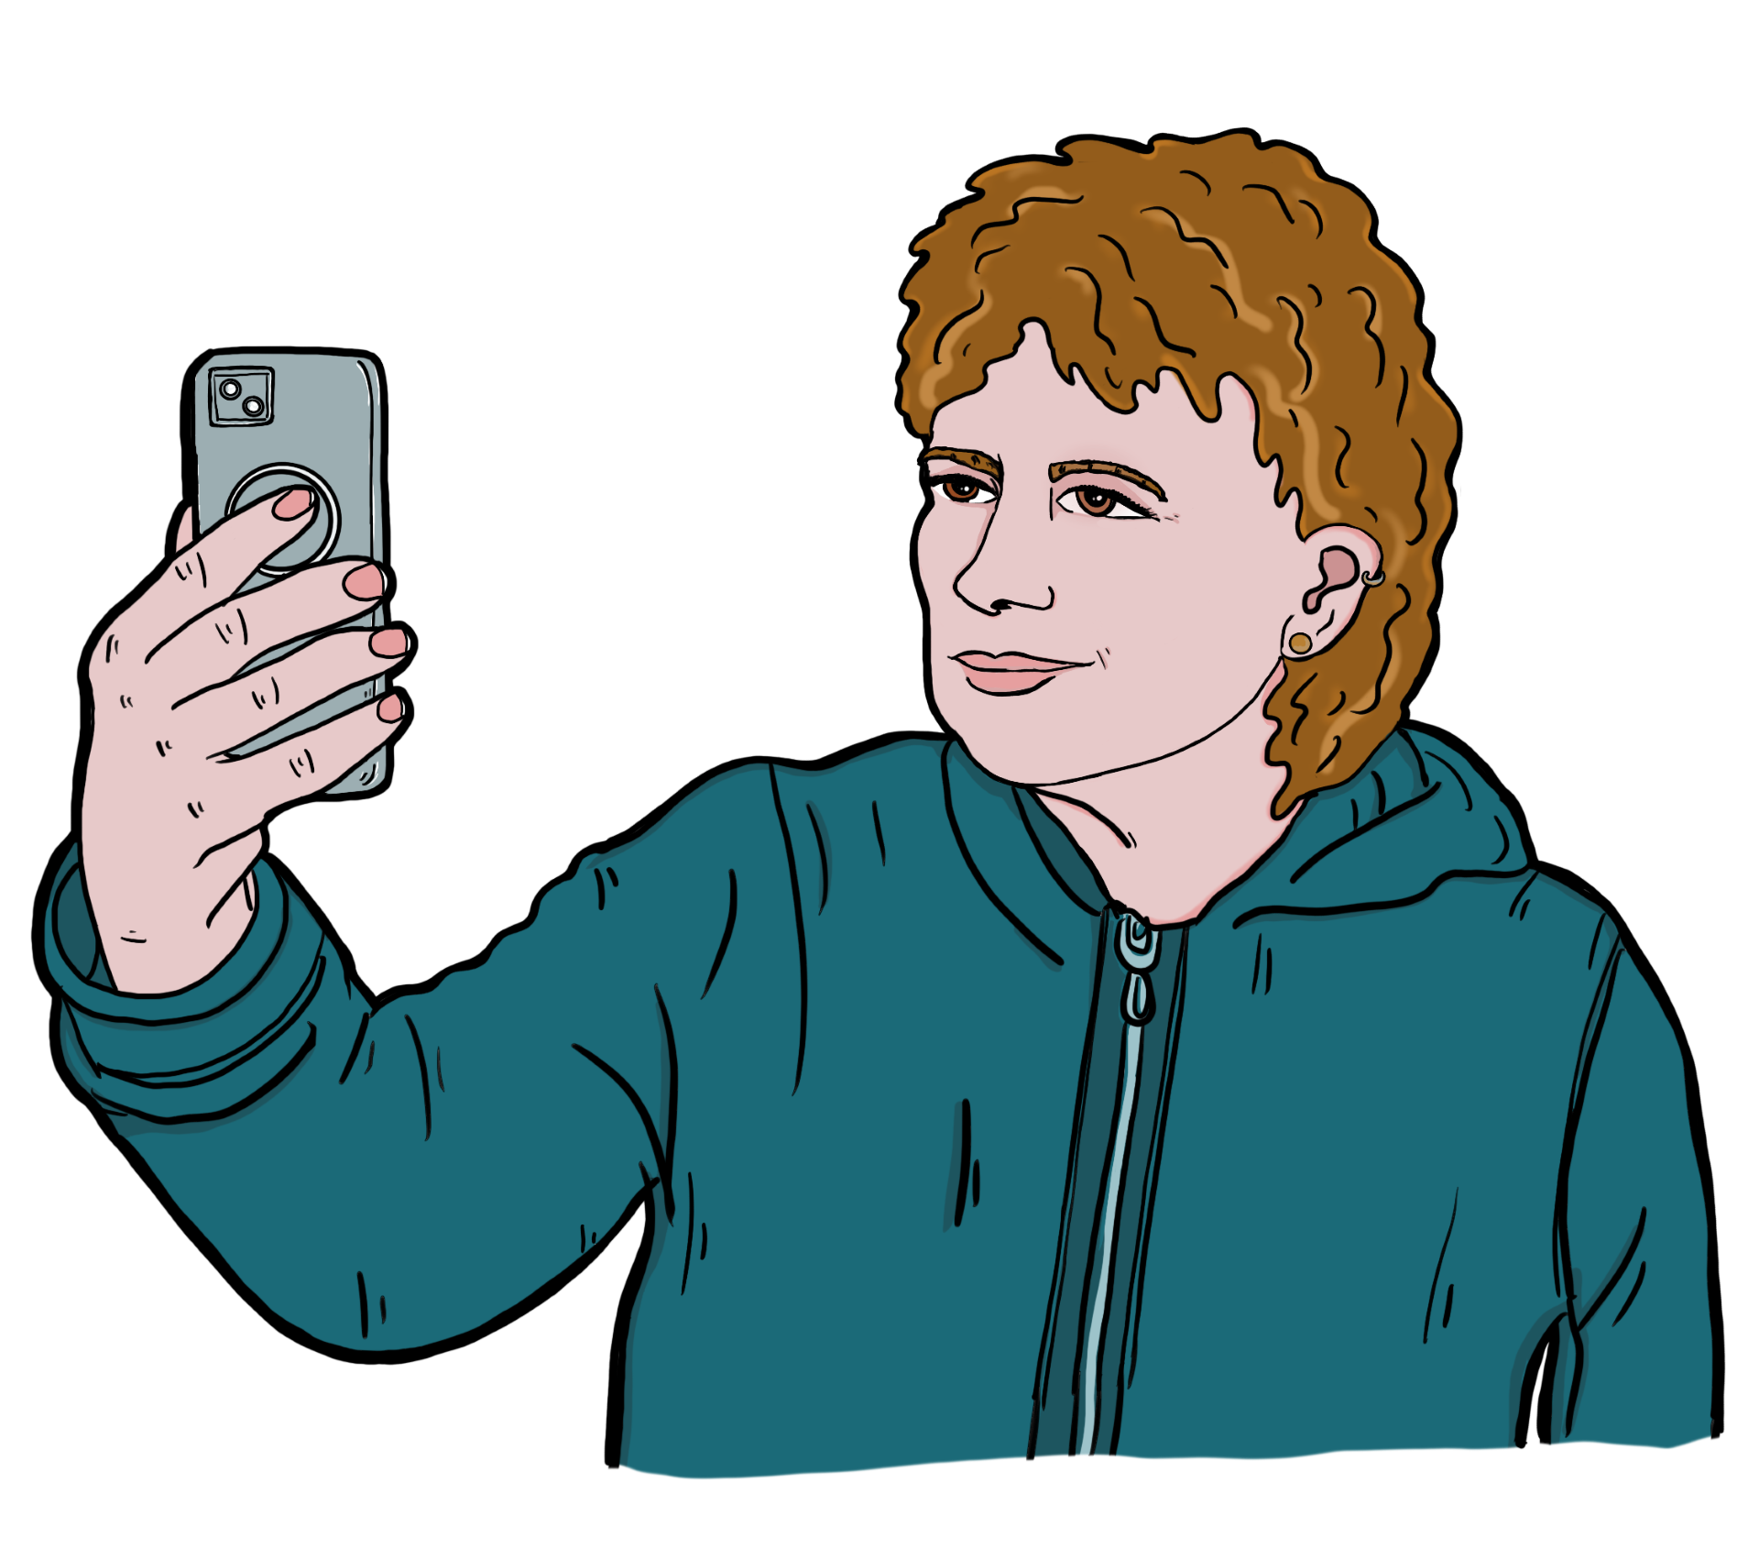
- a photo of you
- your address
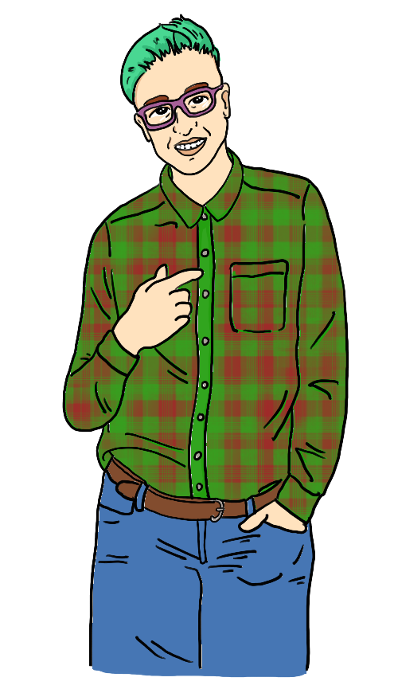
- your age
- your gender
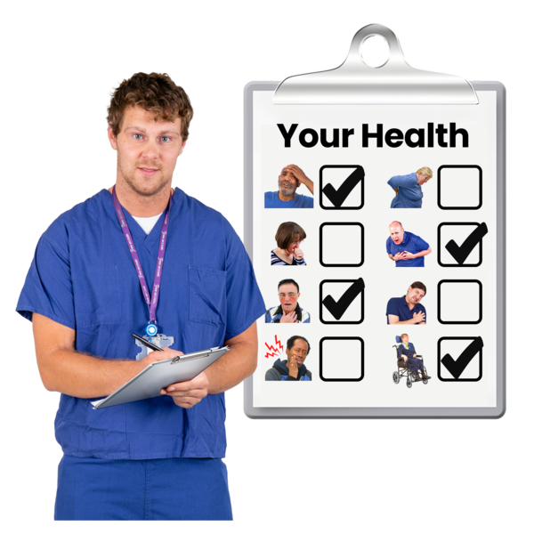
- information about what you look like
- information about your health
- the places you like to visit.

Gender is if you are:
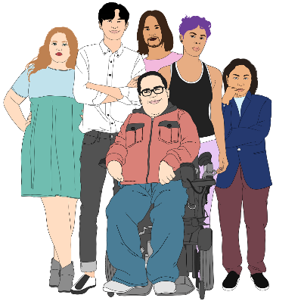
- a man or boy

- a woman or girl

- nonbinary
- another gender.

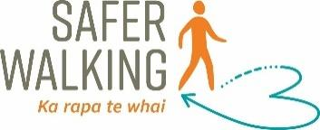
The profile form is on our Safer Walking website at:
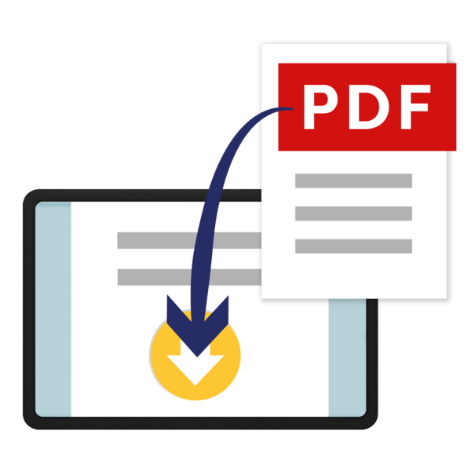
https://tinyurl.com/SaferWalking

The Safer Walking profile form is a PDF document.
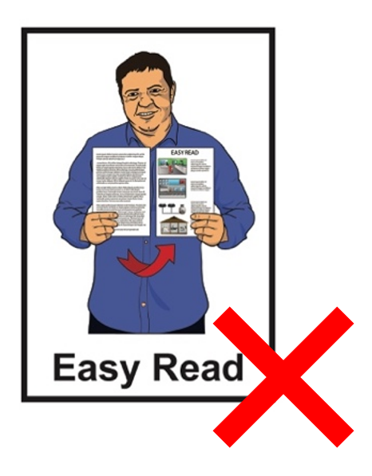

This profile form is not in Easy Read.


Looking after the form

You need to look after your Safer Walking profile form if you fill one out.

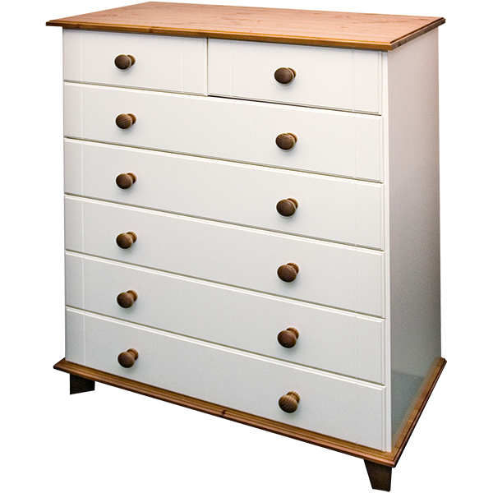
Keep this information:
- in a safe place
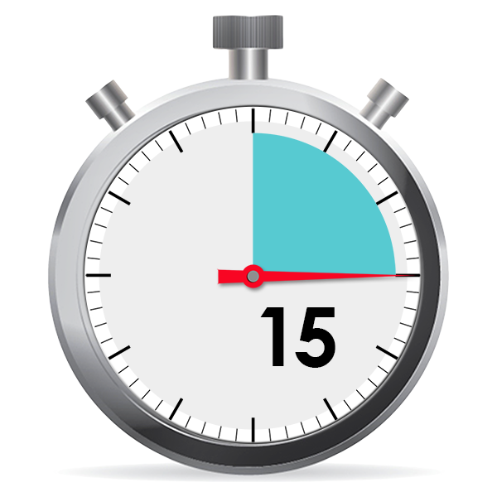
- somewhere it can be found:
- easily
- quickly.

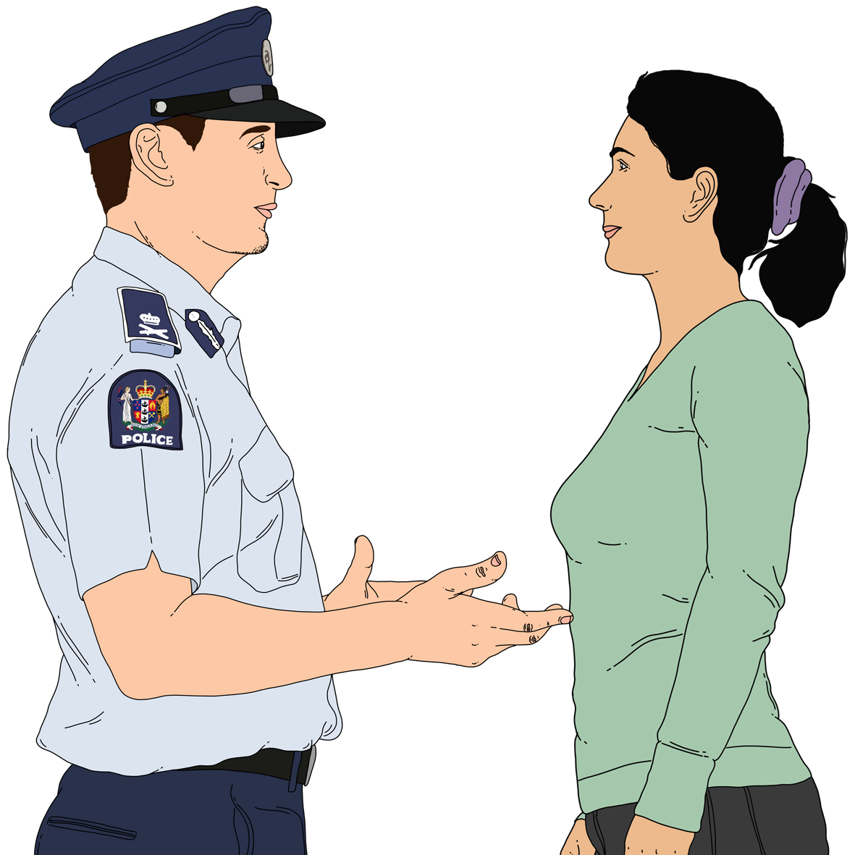
It is important your profile form can be found quickly to give to the Police if you get lost.
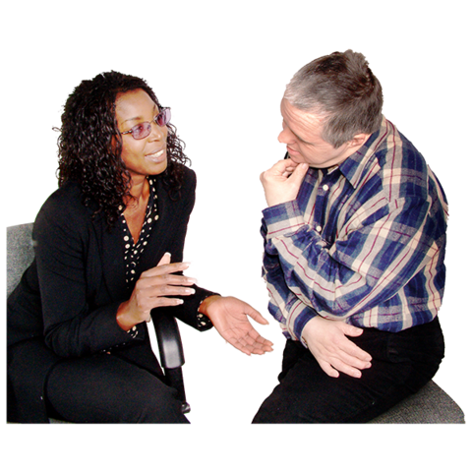
Tell people where your profile form is like your:
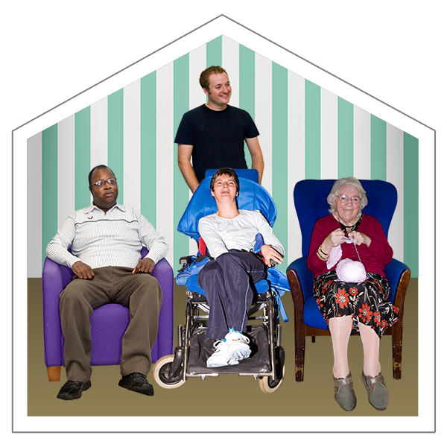
- family
- caregivers.

Someone you trust can keep the form for you.

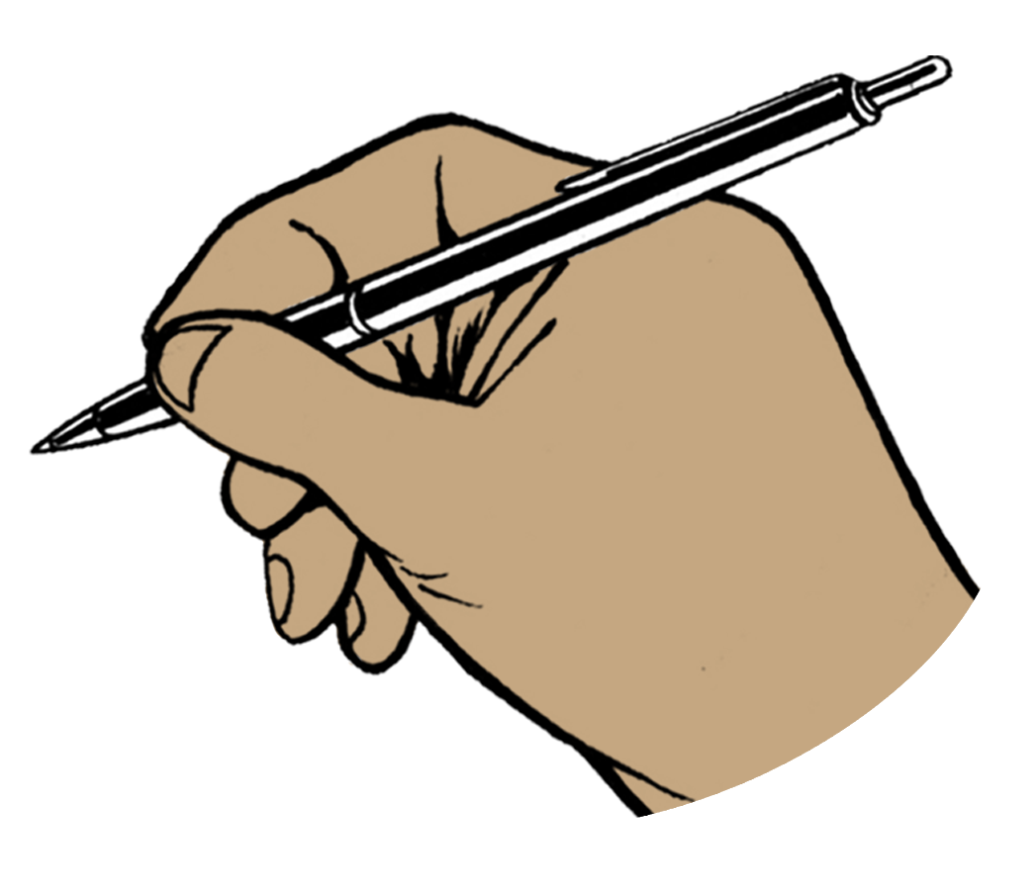
Remember to change your profile form if your information changes like you move to a new address.

Tips to stay safe

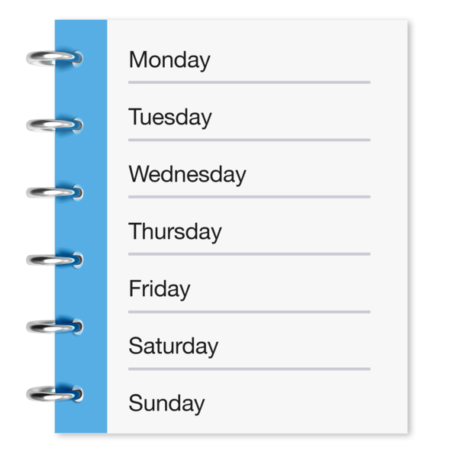

Tip 1

Have a daily routine.

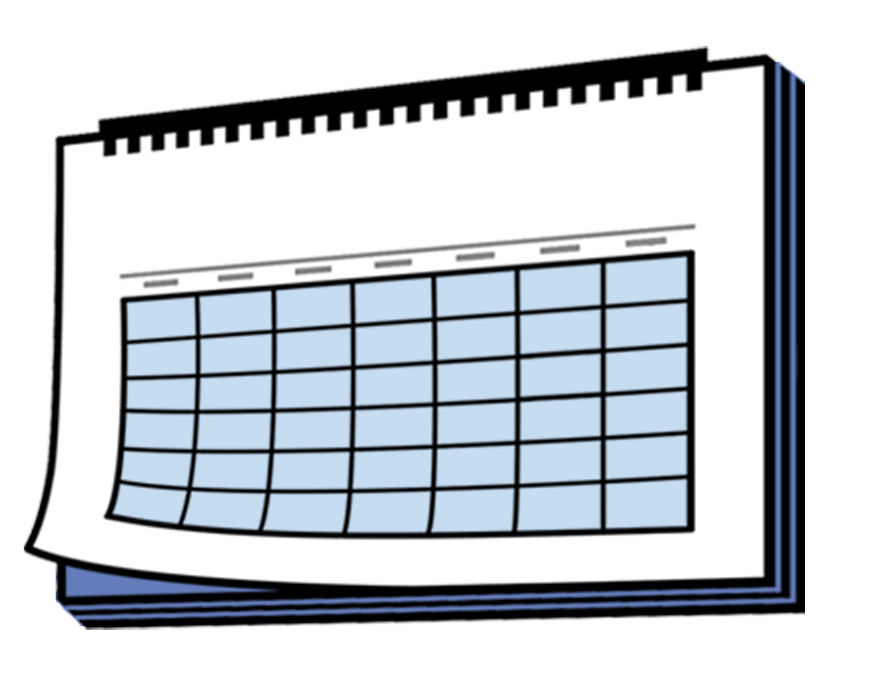
Here a daily routine means the things you do at the same time each day of the week.

Tip 2

Tell people where you are going when you are going out for a walk.

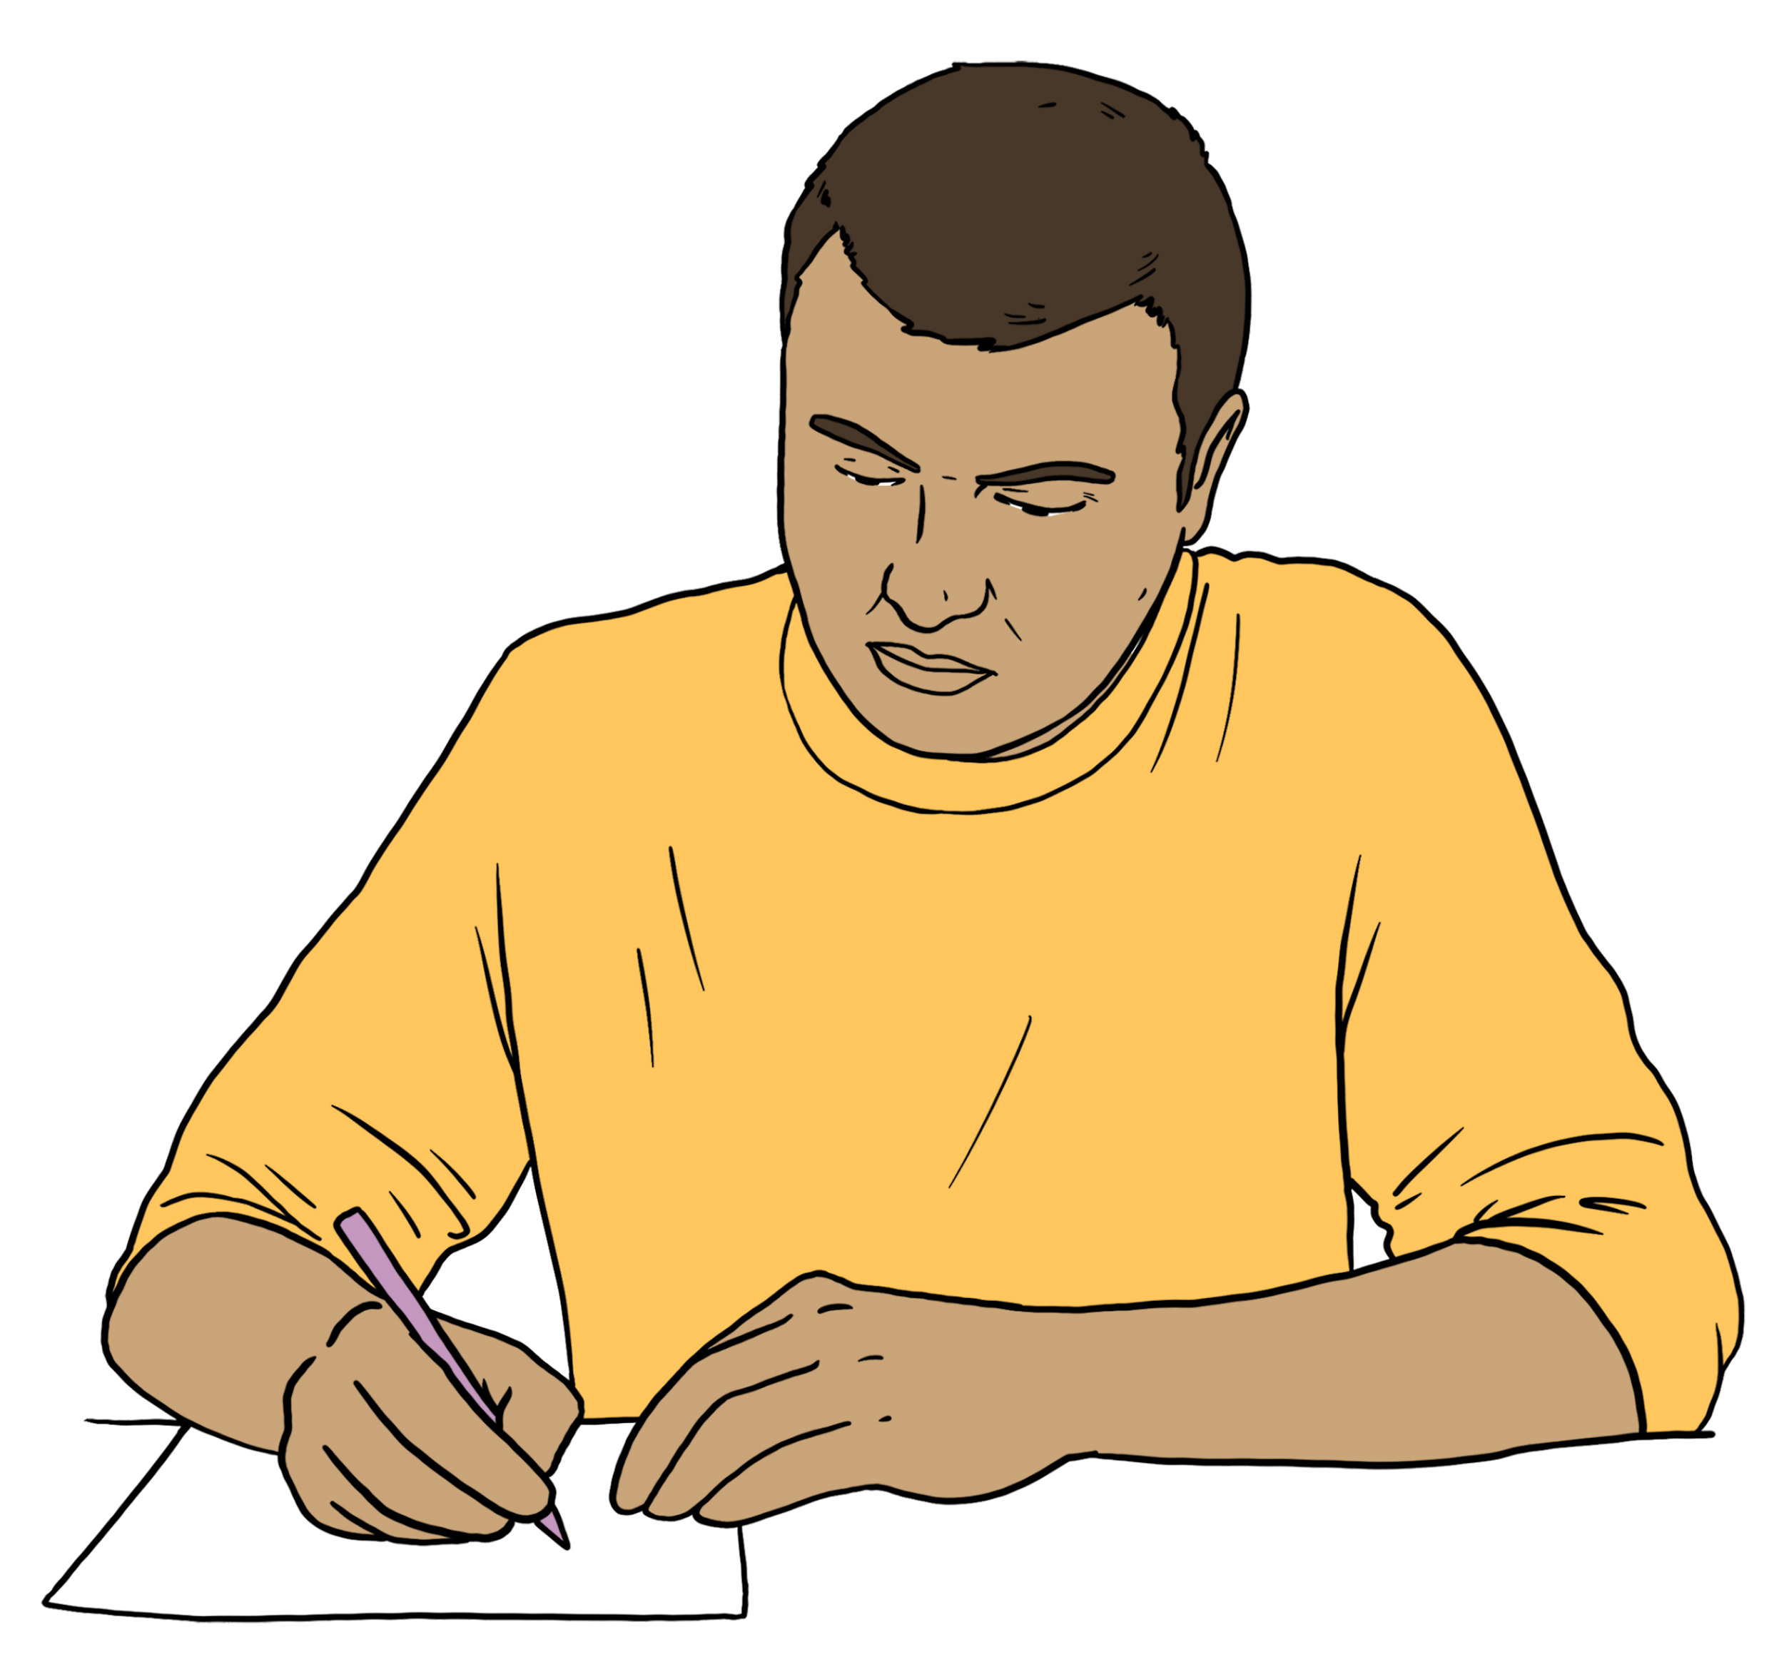
Tip 3

Write down where you are going when you are going out.

Tip 4

Walk in a group with your:
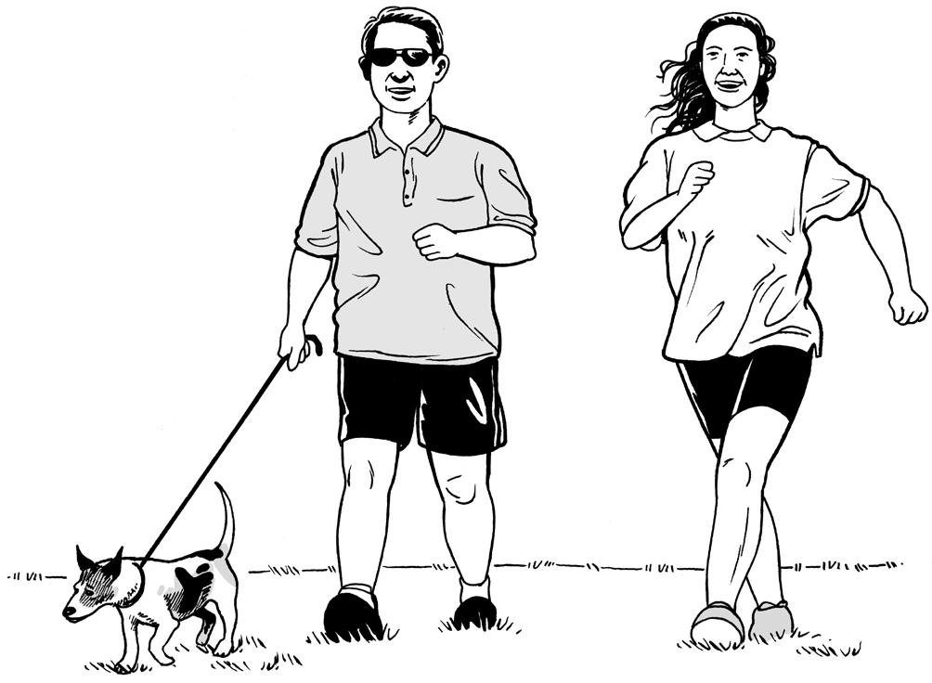
- family
- friends.

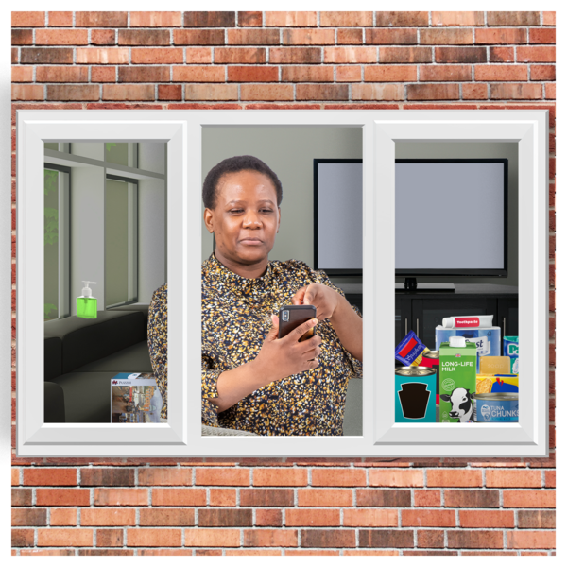

Tip 5

Do things:
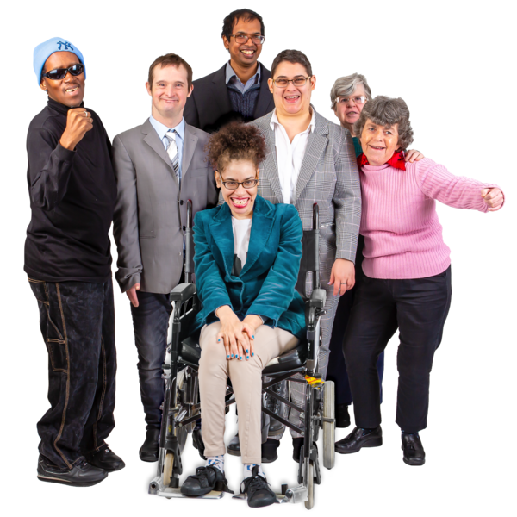
- inside
- at home
- as part of a group.

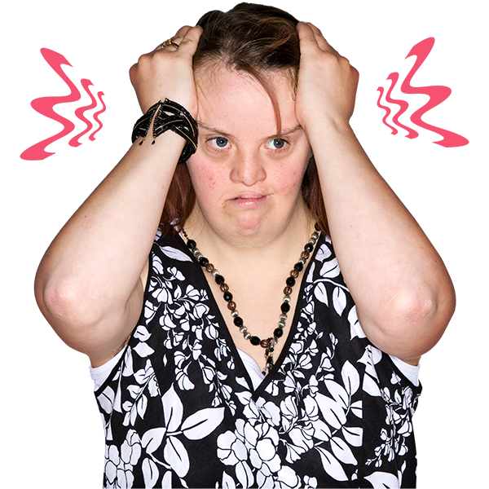

Tip 6

Try not to go to very busy places that you might find confusing.

How to get more support

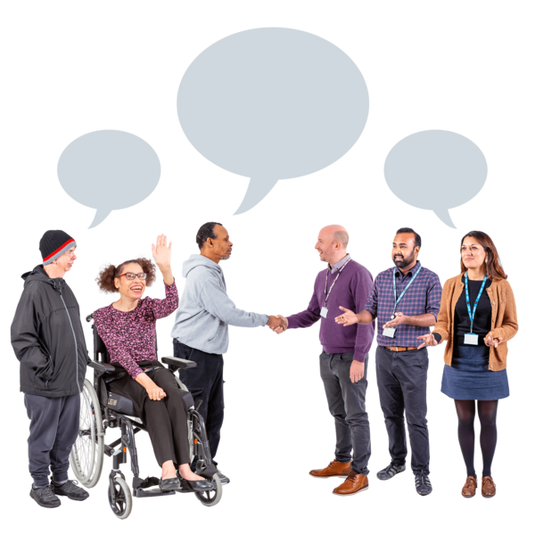
Talk to people about how to stay safe like your:
- family
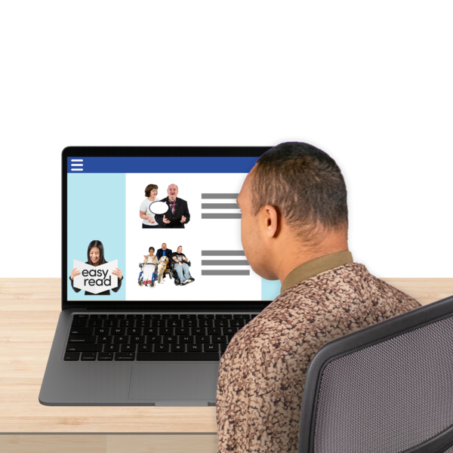
- caregivers.

Find out about the tools made to support you to stay safe.

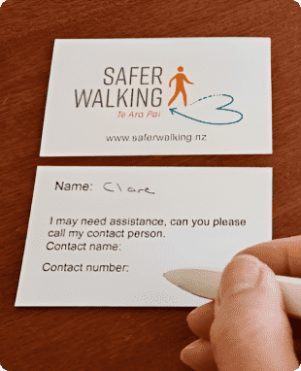
Safer Walking tools are things like:
- an identification card like a Safer Walking identification card
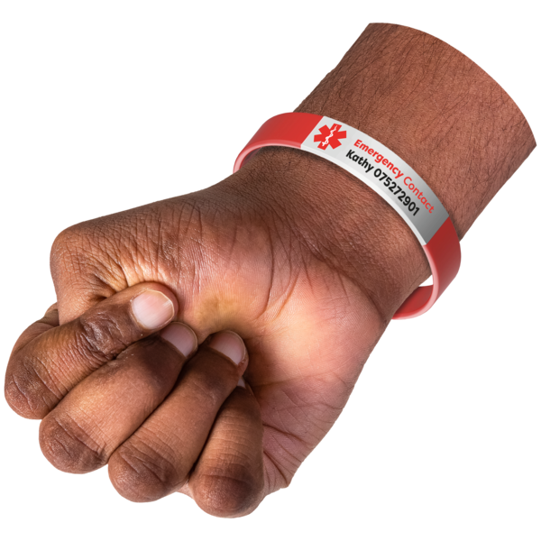
- an identification bracelet that has your name on it.
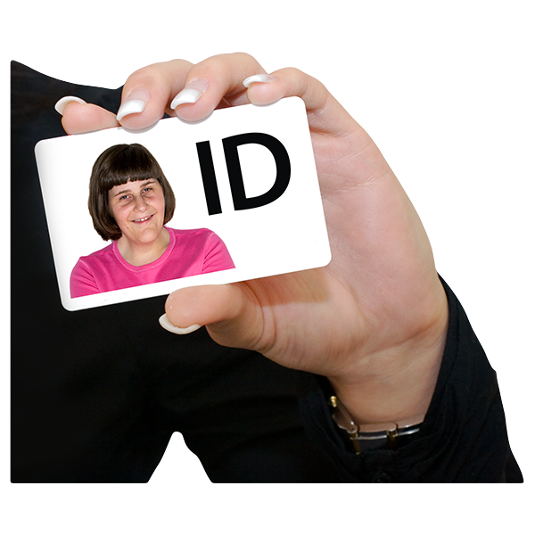

Here identification is something that says who you are.
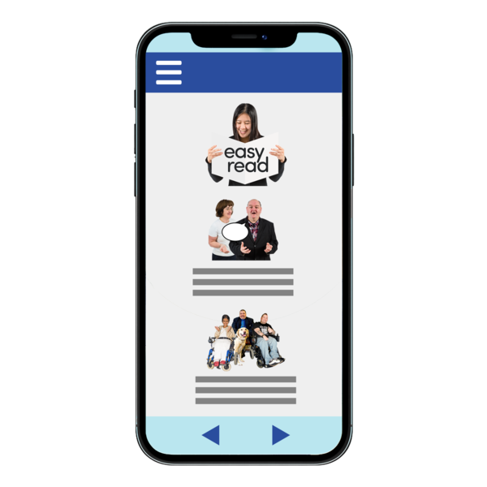
Safer Walking tools are also things like:

- apps on your phone that can track you like:
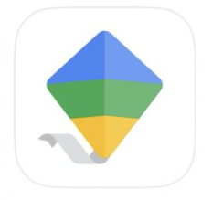
- Life360
- Google Family Link
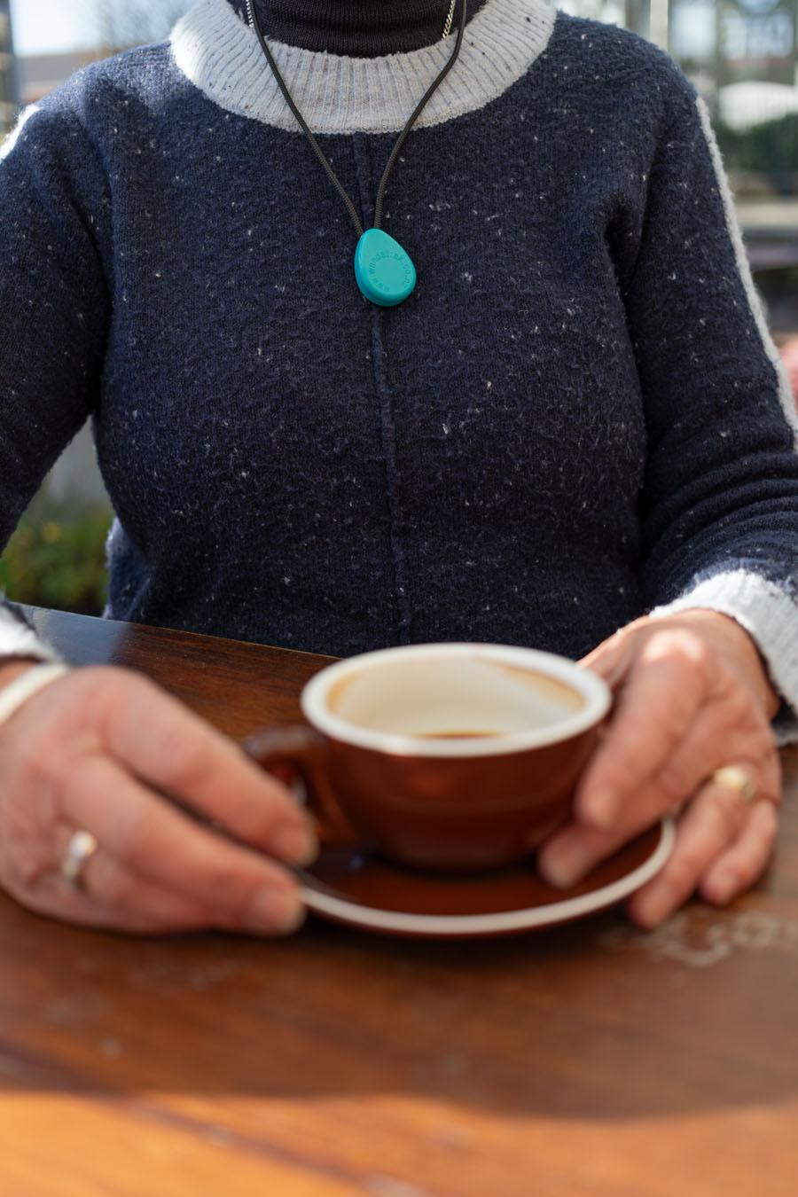
- a radio frequency device like WanderSearch that you can wear as a:

- necklace
- bracelet
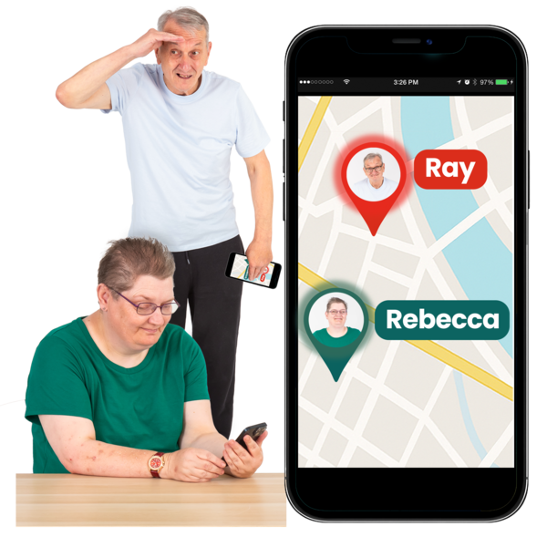
- a Bluetooth device to support others to find you like:
- a SmartTag
- an AirTag.

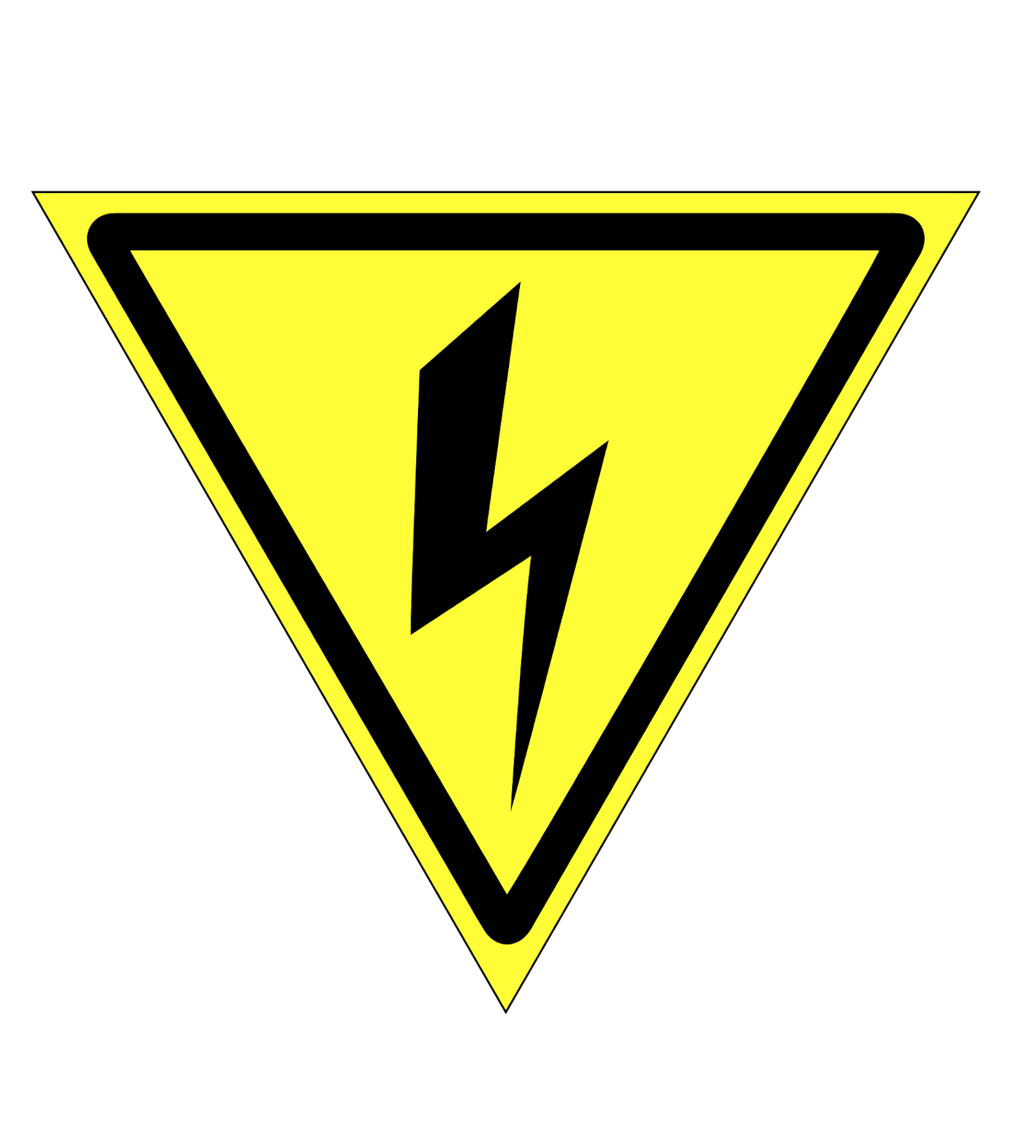
Here a radio frequency device gives off a signal that tells people looking for you where you are.

These are just some of the tools that can be used to support people at risk of getting lost.

You will need to use the tool that:
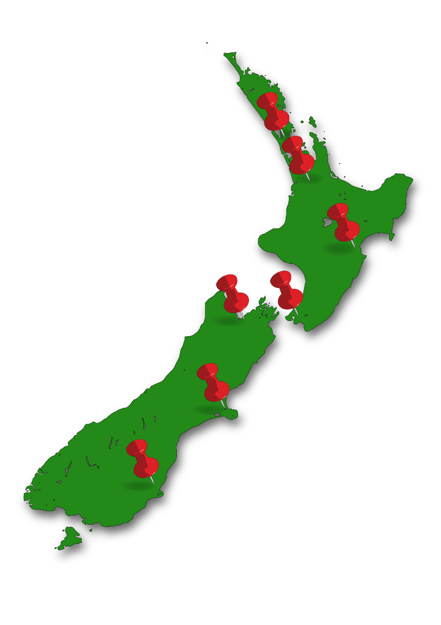

- is right for you

- works in the area where you live in.
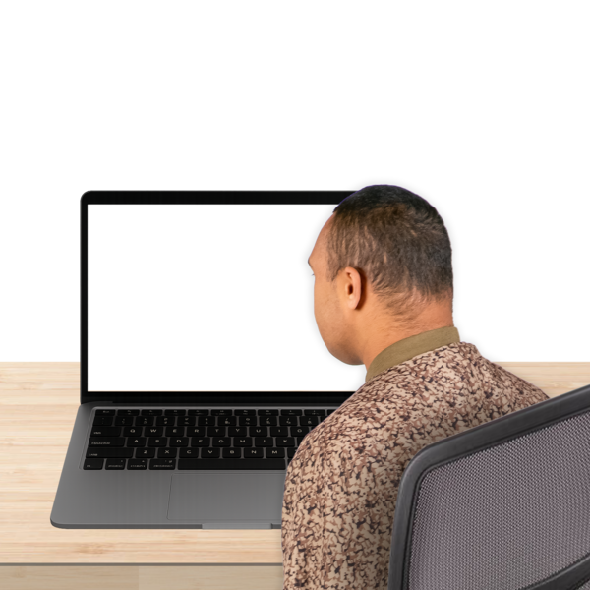

Information will be put on our Safer Walking website when a:
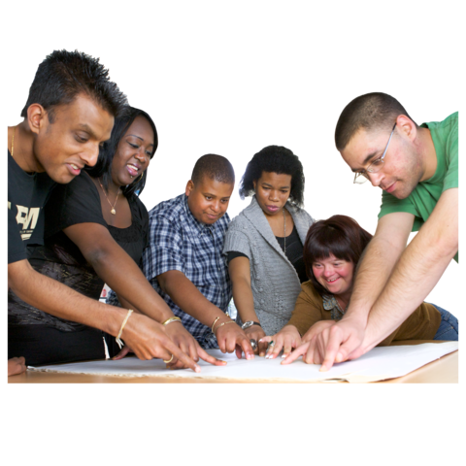
- tool is updated / made better
- new tool is developed / made.

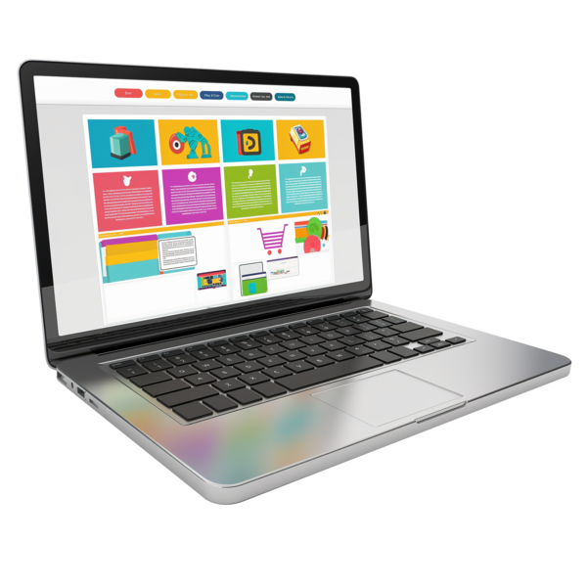
You can find out more information about these tools at our website:

https://saferwalking.nz

This website is not in Easy Read.

How to contact us

Find out more information about the Safer Walking framework by visiting our website at:

https://saferwalking.nz

This website is not in Easy Read.

You can contact our Safer Walking team by:
- calling us:
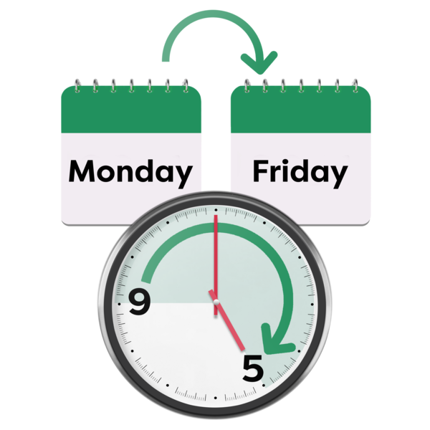
- Monday to Friday
- from 9 am to 5 pm on:
03 357 4441
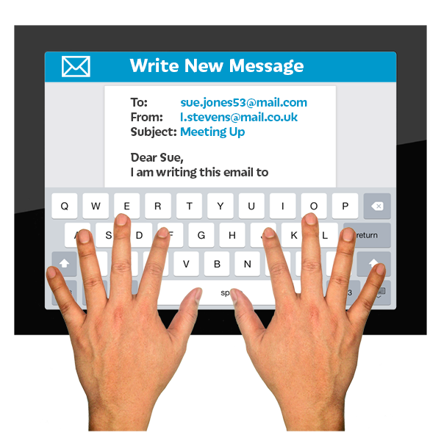
- emailing us at
saferwalking@landsar.org.nz

If you find it hard to use the phone the New Zealand Relay service is for people who are:

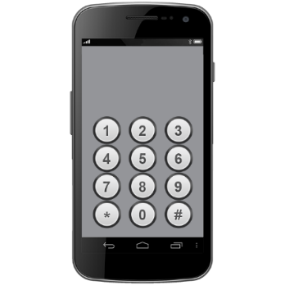
- Deaf / hard of hearing

- deafblind

- speech impaired / find it hard to talk.

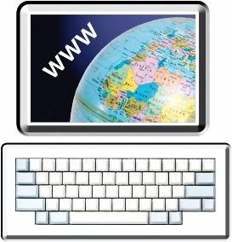
You can find out more about the New Zealand Relay service at:

www.nzrelay.co.nz
This information has been written by
Safer Walking – Ka rapa te whai.


It has been translated into Easy Read by the Make it Easy Kia Māmā Mai service of People First New Zealand Ngā Tāngata Tuatahi.

The ideas in this document are not the ideas of People First New Zealand Ngā Tāngata Tuatahi.

All images used in this Easy Read document are subject to copyright rules and cannot be used without permission.


Make it Easy uses images from:


- Photosymbols

- Change Images


- Huriana Kopeke-Te Aho

- SGC Image Works

- T Wood


- Studio Rebeko

- Inga Kramer.

